Project / Subproject  IDA/EINRC framework 501998  Specific Agreement-4/EIONET | Authors  TietoEnator Corporation | Date issued / Version  7 June 2001/0.3 | Specifications Report
Client  European Commission  DG Environment / B 1 | Info  Software Requirements and Architectural Design for META |  | Reference / Page  0000.doc  / 1 of 61

EUROPEAN COMMISSION
ENVIRONMENT DIRECTORATE-GENERAL
IDA-Programme -Framework Contract No 501 998 - 4th Specific Agreement

Einrc - Eionet

Software requirements and
Architectural design
META: Common tool for Environmental Metadata in EIONET

Modification history

Date | Version | Authors | Reason for modification
30.4.2001 | V0.1 | J. Heinlaid | First internal draft
21.5.2001 | V0.2 | K. Lounamaa | XML Schema format data definitions
21.5.2001 | V0.2 | J.Heinlaid | UI views, CR data model, Communications with clients, administrative attributes
7.6.2001 | v0.3 | J.Heinlaid | Updates to UI views, introduction chapter, minor additions by Project Manager

APPROVAL PROCEDURE
Reviewer | Version(-s) | Start  Date | Finish  Date | Required modification/Approval/Comments
Project Team |  | 21.05.01 | 28.05.01 | Project Mgr approved with some comments
Project Leader | v02 | 21.05.01 | 28.0501 | Approved with some requests for modifications to UI
NMC-CIRCLE User Group | v03 | 7.06.01 | 11.06.01 | Approved in Faro meeting
Einrc Mgt Team | v03 | 18.07.01 | 06.08.01
Project Officer

TABLE OF CONTENTS
1. Software specifications 4
1.1 Purpose of this document 4
1.2 Scope of the software 4
1.3 User Interface functionality 6
1.3.1 Entrance views 6
1.3.2 Data dictionary views 8
1.3.3 Content registry views 15
1.3.4 Administrative views 19
1.3.5 Confirmation views 19
2. Data Model 21
2.1 Class diagram of the Data dictionary 21
2.2 Database model of the Data dictionary 23
2.3 Database model of the Content registry 25
3. Architecture 26
3.1 Interfaces to the Metadata system 26
3.2 System architecture 27
3.3 Communication between Content registry and its client applications 29
3.3.1 General solution 29
3.3.2 Concrete solutions - CIRCA 30
3.4 Communication between Data dictionary and its client applications 35
4. XML Schema format data definitions 37
4.1 XML representation of ISO 11179 attributes 37
4.1.1 Name 38
4.1.2 Identifier 38
4.1.3 Version 39
4.1.4 Registration authority 39
4.1.5 and 4.1.6 Synonymous name and Context 40
4.1.7 Definition 40
4.1.8 Classification scheme 41
4.1.9 Keyword 41
4.1.10 Related data reference and Type of relationship 42
4.1.11 Representation category 43
4.1.12 Form of representation and 4.1.13 Datatype of element values 43
4.1.14 and 4.1.15 Maximum and minimum size of data element values 46
4.1.16 Layout of representation 48
4.1.17 Permissible data element values 49
4.1.18 Responsible organisation (RO) 51
4.1.19 Registration status 51
4.1.20 Submitting organisation (SO) 52
4.1.21 Comments 53
5. Codes 56
5.1 The definition of codes 56
5.2 The usage of codes 57
6. Units of quantity 58
6.1 The definition of units 58
6.2 The usage of units 58
7. Administrative metadata 60

Software specifications

Purpose of this document

META system is developed using object oriented software development process. It uses UML-notation and Rational Rose ObjectCase tool for documenting the specifications and designs during the development process. Way of working is iterative, and proceeds via prototyping. This document contains preliminary user interface design for an interface prototype, preliminary data models for Data dictionary and Content Registry and Architectural design for the META system. The document and interface prototype are tools for discussing and specifying the functionality for the system with the customer and with user representatives.

The preliminary designs in this document will change to some extent during next iterative phase, the Detailed Design and Implementation phase. The feedback from the users in NMC CIRCLE user group (June 11-12, 2001) to the prototype (MetaUIProto v03 , see EEA's Circle, NMC Circle UG meeting library section) will be included in the final interface design. The final designs, if changed from those in this document, will be documented in the Detailed Design document. During the implementation phase a recent version of the interface prototype is uploaded into the project's library for the users to download and comment.

Scope of the software

- Data dictionary

  - User interface
    - Searching, viewing, modifying, adding, deleting, importing, exporting data definitions.
    - Links to other EIONET sites
    - Administrative user interface for managing user accounts and definitions’ attributes
    - HTTP session based login/ logoff
  - Background application
    - Automatic (transparent for the user) generation of XML Schemas for data exchange formats
    - Automatic (transparent for the user) parsing of data exchange formats in XML Schema form
    - Automatic (transparent for the user) management of schema repository
    - HTTP content type: text/xml interface for other EIONET applications in need of XML Schema form data exchange formats
  - Schema repository
    - XML Schemas stored in files that are shared out by the Web server

- Content registry

  - User interface
    - Searching, browsing, modifying, adding, deleting content descriptions (not the contents themselves!)
    - Links to other EIONET sites
    - Administrative user interface for managing user accounts, content descriptions’ attributes, scope and frequency of the descriptions harvesting
    - HTTP session based login/ logoff
  - Background application
    - Automatic (transparent for the user) search and harvesting of descriptions of newly updated/uploaded contents in EIONET repositories taken into registry’s harvesting scope
    - Gateways to CIRCA API to search and retrieve content descriptions in CIRCA
    - Possible gateways (API, CGI, ...) to other EIONET sites, but each case has to be analysed and implemented separately and only with additional resources to the project’s current budget

What about gateways to WebROD, to the EERC?

- General

  - User interfaces of the Data dictionary and Content registry shall be integrated into single access point
  - Data dictionary and Content registry will have separate databases

User Interface functionality
User interface is to become entirely web-based, leaving a web-browser as the whole client side software. Thus the “thickness” of the client side software is entirely determined by the “thickness” of the web-browser.
The web-based software must be compliant with all commonly spread and used browsers, primarily Internet Explorer and Netscape.

User interface must follow the rules of:

- being clear, simple and uniquely understood while still providing all the functionality set by the user requirements
- being built of blocks and components that will not cause unreasoned slowing down of the using process of the interface
- providing maximum flexibility and various options of “playing around” with the data with the least amount of different views and divisibility
- being consistent and familiar throughout all of its different user views and forms
- leaving an impression of a handy tool that will enable the users to take advantage of a wide range of functionality without too much clicking around and wandering in deep using paths

As the Data dictionary and Content registry must be integrated as one complex system, so shall be the user interfaces for the two. This means that the user interfaces for the two sub-systems will have a common starting point and authorizing page, and it must be enabled to switch between the systems without too much views and forms to go through.
It is recommended to use as much as possible common buttons and clickable images that would be constantly accessible throughout all the user views and forms, thus providing a tool-like ability to access the system’s main functionalities from anywhere and any time in it using process.
The user interface of meta should also provide links to other EIONET sites that will closely related and co-operating with the system. Those links should be always visible throughout the different user views, thus being quickly accessible at any step in the different user paths where they might become needed.

Entrance views

The beginning views for the Data dictionary and Content registry would be the pages representing the entrance and authorizing canal to the META system. Those common views shall introduce the META system by covering its purpose and main possibilities for usage. A draft view of such entrance views is given on the figures 1 and 2.
The view on figure 1 should become the interface’s starting point where the users (or guests) will be shortly introduced to the system and then provided with the ability to log into the system or use it as a guest.
Figure 2 represents a view that would follow figure 1 and allow the users to make a selection between entering the Data dictionary and the Content registry. Before doing so, users must be provided with a short introduction and explanation of what awaits them.

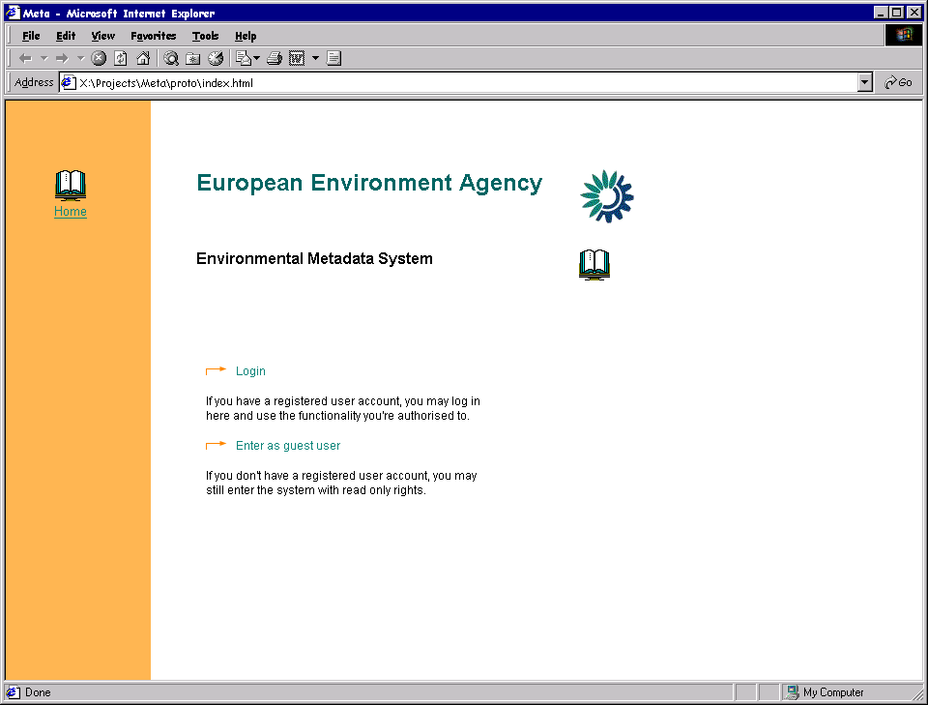
Figure 1. Entrance view for the META system.

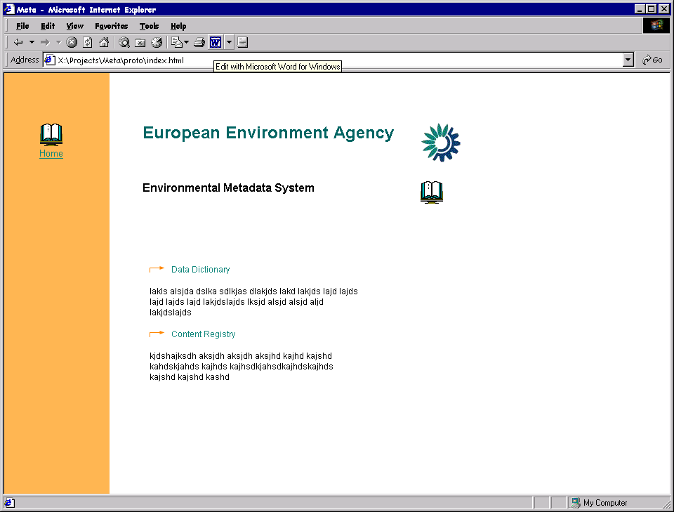

Figure 2. Entrances to the Data dictionary and Content registry

Data dictionary views

The opening view of the Data dictionary shall at once provide user with access to the following top-level functionalities:
- search/browse the data definitions
- add new data definitions
- import new data definitions
what about:
export new data definitions?

One of the above functionalities – search/browse (and also select from result set for modifying/deleting/exporting) data definitions – is actually displayed on the opening view right away, thus enabling the user to get started as quick as possible.
The opening view as well as all the other view described below shall also provide links to co-operating EIONET sites. These links are provided as the header of the user views, displayed in the upper part of the views.
Opening view is described on figure 3. The corresponding use case is given on figure 4.

Searching/browsing view, besides enabling specification of criteria by definition attributes, also provides ability to specify one of the three data element types to search or browse in:

- Data elements with fixed value range
- Data elements with values measured in units
- Aggregate data elements, having no values, but consisting of the above two

Each of the three data element categories is provided with the same functionalities.

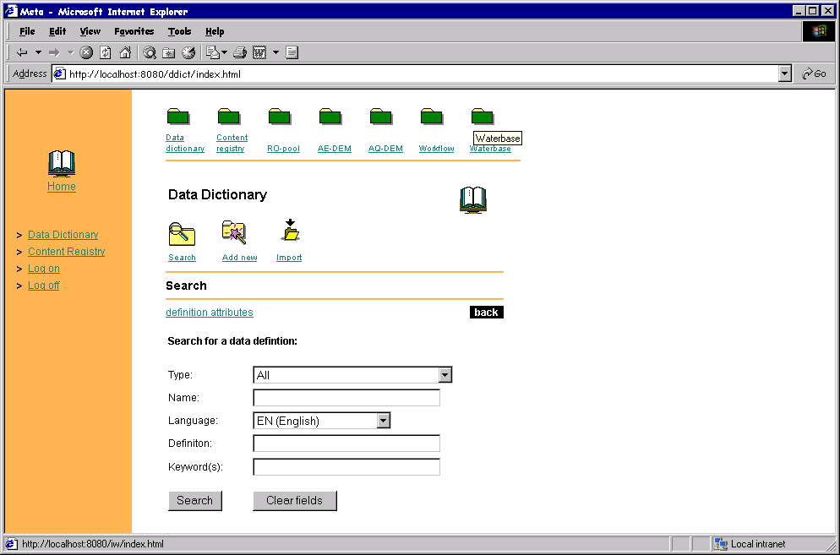
Figure 3. Opening (and conjointly searching/browsing) view of the Data dictionary

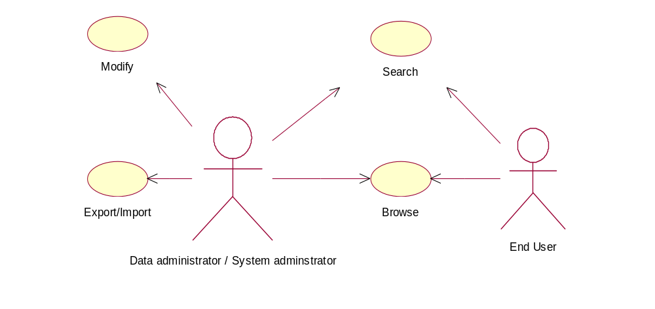
Figure 4. Use cases for the opening view of the Data dictionary

Result set view (figure 5) presents the resulting list of the search, each element in the list representing a data definition with its name, last update and link to its corresponding schema given in columns. In addition result set view opens access to three more functionalities:
- modify data definitions
- delete selected data definitions
- export selected data definitions
Deleting and exporting functionalities are presented with the ability to mark one or several of the listed definitions and press the buttons of either deletion or export of the marked definitions.

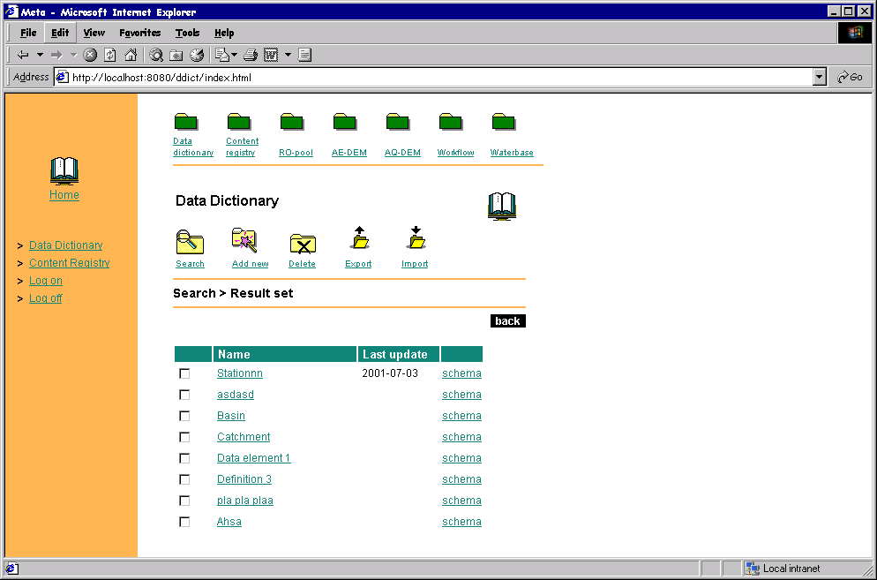
Figure 5. Result set view of the search in Data dictionary

Import view (figure 6) for the data dictionary enables users to import new data definitions in XML Schema format. For that, the import view enables to select the desired XML Schema file from hard-disc and by submitting the selected schema file to the Data dictionary, it will be stored to the schema repository and processed for gathering and saving metadata into the database as well.
Importing view does not depend on the type of the defined data element, so it’s the same both for the aggregates and characteristics.
Note that importing view also requires specification of several administrative attributes from the user. The meaning and the origins of those attributes are more closely explained in chapters below.

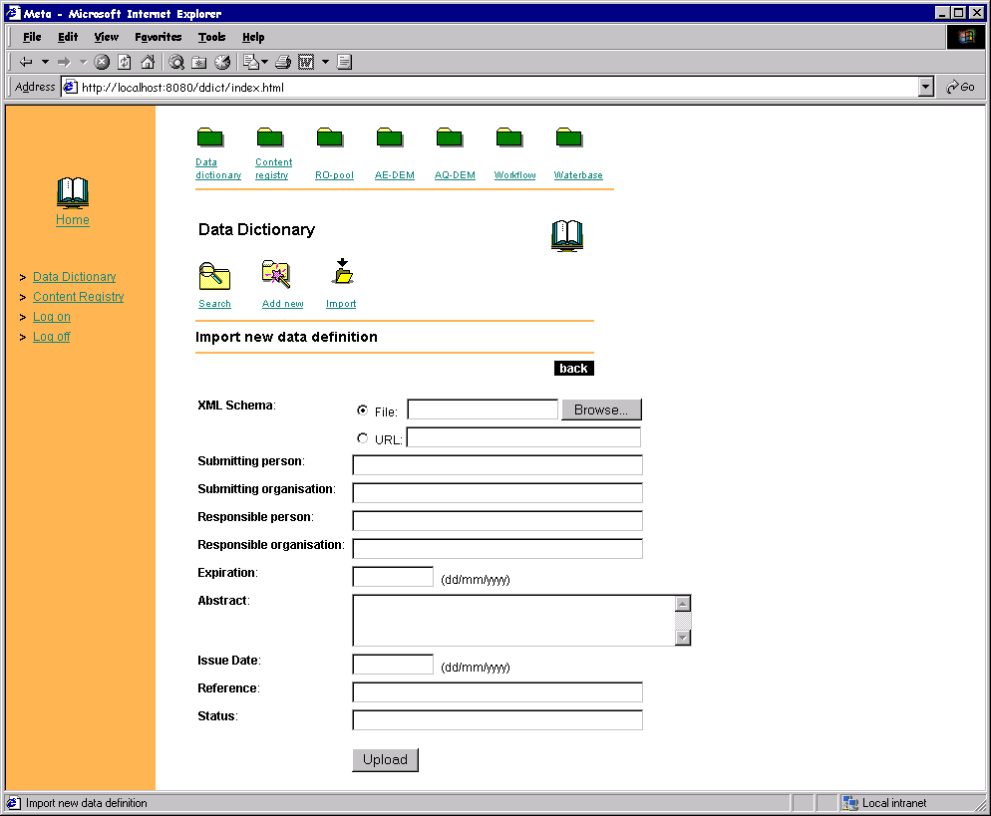

Figure 6. Importing view of the Data dictionary
Scroll list should be provided, representing the CIRCA links to persons, organisations

Modifying view (figure 7), unlike previous views, depends on the type of the defined data elements, so it’s different for the aggregates and also for both types of the characteristics. That is because all those three different types of data definitions have different sets of definition fields and in addition to that aggregates also have a structure of their own- consisting of characteristics.
Modifying view is reached by pressing a data definition’s link in the resulting list of the search and the one for an aggregate data definition is presented on figure 7.

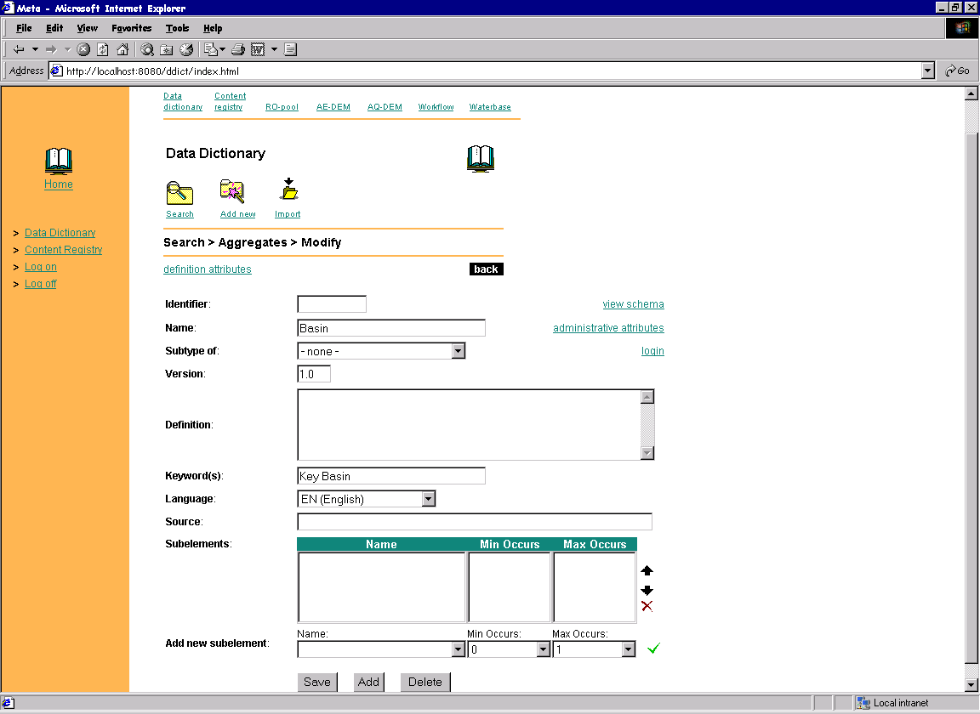
Figure 7. Data dictionary’s modifying view of an aggregate data definition

The definition fields should be pre-filled with sources from GEMET and other terminologies (e-.g. EUROSTAT dictionaries).

A status of the definition process should be assignable.

Notice that that the lower region of an aggregate’s modifying view is meant for modifying the structure that consists of existing and predefined characteristics. One can add new sub-elements to the structure by selecting a characteristic from a drop-down list. Already existing sub-elements can be removed from the structure and their order can be changed by moving selected elements up or down. Also, every sub-element has two attributes for specifying the amount of minimum and maximum occurrences of that sub-element in the given structure.
The upper region of the aggregate’s modifying view is meant for editing ordinary definition fields of which the name, definition and language are most natural to specify.
Also there is a possibility to select a base data element the subtype of which the currently modifiable data element must become. Being a subtype of another data element means inheriting the structure of that data element (so this is more a less applicable to aggregates only). This could be compared to class extending in object-orientated programming.

The corresponding use case for the aggregate’s modifying view is given on figure 8 where the “bubble” entitled ‘Define a relation between definitions’ corresponds to the modification of an aggregates structure, described above.

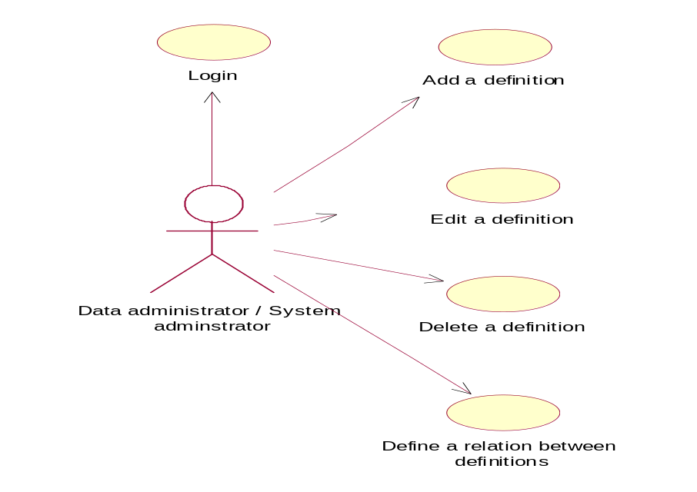
Figure 8. Use cases for the modifying view of an aggregate data definition

Modifying view for type 1 characteristics or in other words data elements with fixed value range is given on the figure 9. Again pay closer attention to the lower region of the view which is meant for modifying the set of the fixed values. New values can be typed into a text input and added to the set with a mouse click and already existing values can be selected and removed from the set.

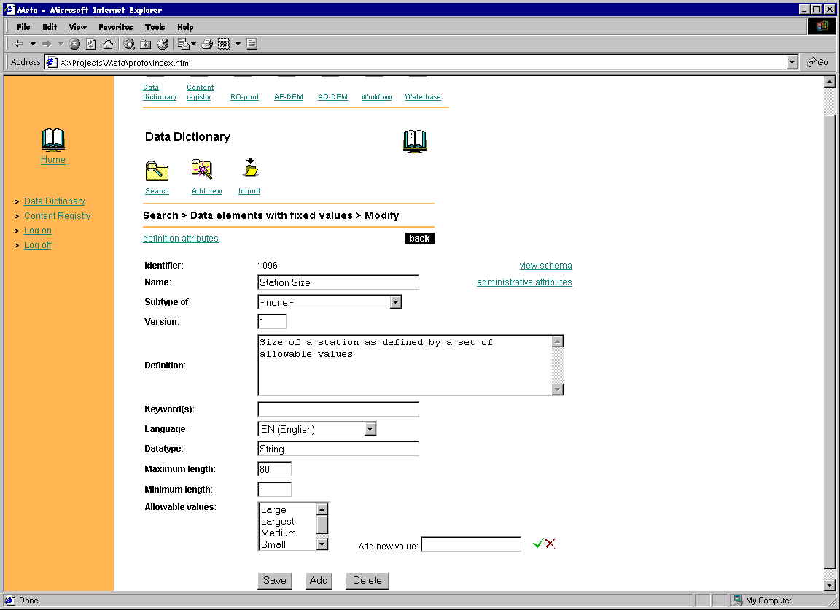

Figure 9. Data dictionary’s modifying view for a type 1 characteristic’s definition
Modifying view for type 2 characteristics or in other words data elements with values measured in units is given on the figure 10. Of the three modifying views this is the simplest. All a user has to do here is to specify the data definition fields of which the mandatory ones are represented on the figure.

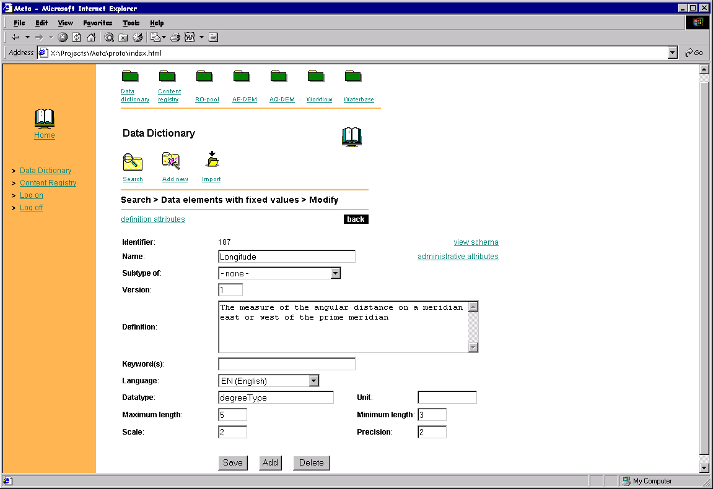

Figure 10. Data dictionary’s modifying view for a type 2 characteristic’s definition

Note that the use cases for the characteristics’ modifying views are the same as on the figure 8, with the exception that the ‘Define relations between definitions’ use case should be excluded.

Adding new definition views are the same as the above described modifying views, with the exception that the inputs will be left empty to be filled with new data. Therefore no explicit figures are given here for that functionality. Note that switching between the adding views of different data element types is done by selecting one of the three options in the data element type’s selection box. A change event there automatically switches the editing page.

Deleting view and exporting view will be simply message boxes, indicating of the failure or success of the deletion or announcing of the start of the downloading process that will be initiated when selecting export of the selected definitions. The latter means that the XML Schemas corresponding to the selected definitions will be packaged into one and prompted for the user to save them somewhere to a hard disc.

Content registry views

The opening view of the Content registry provides user with access to the following top-level functionalities:
- search/browse the content descriptions
- add new data content descriptions
- import new content descriptions

One of the above functionalities –browse (and also select from result set for modifying/deleting/exporting) content descriptions – is actually displayed on the opening view right away, thus enabling the user to get started as quick as possible.
Just like in the case of Data dictionary the opening view as well as all the other view described below shall also provide links to co-operating EIONET sites. These links are provided as the header of the user views, displayed in the upper part of the views
Opening view is with its corresponding use case is given on figure 11.

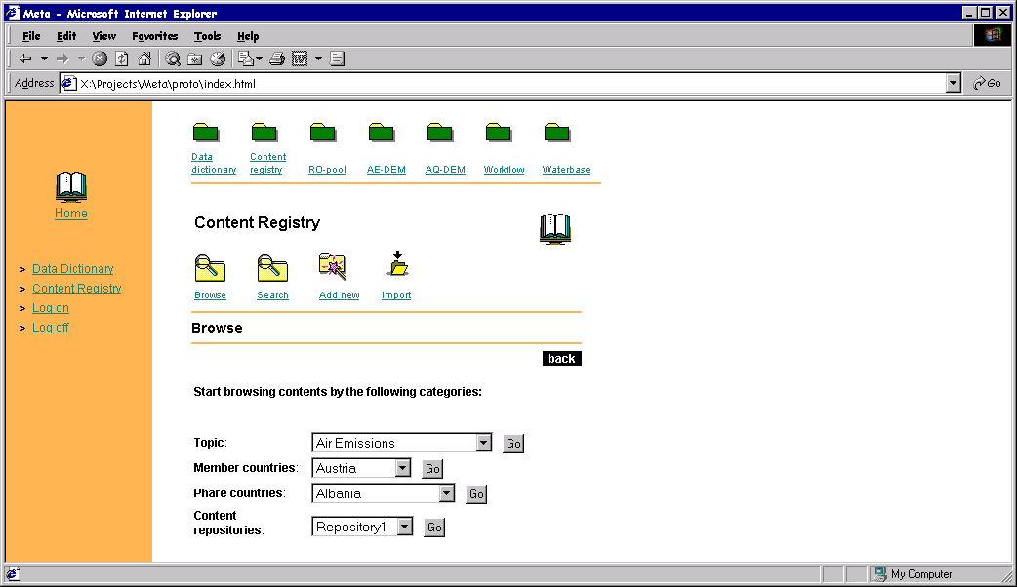
Browsing view (being part of the opening view, thus also represented on figure 11), enables browsing by topic, countries and EIONET content repositories.

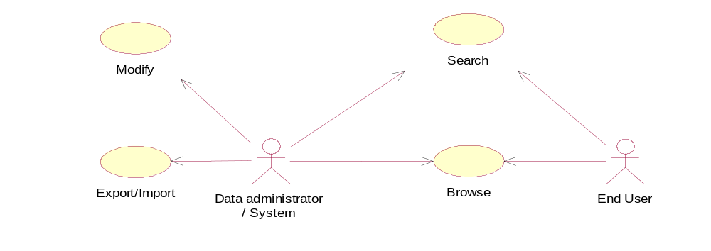
Figure 11. Opening (and conjointly browsing) view and corresponding use case of the Content registry
The pick lists should include the ALL option.

Searching view (represented on figure 12), enables specification of criteria by several description attributes including the type of the described content, which according to Dublin Core’s suggestions can be any of the following:
- Collection
- Dataset
- Event
- Image
- Interactive Resource
- Service
- Software
- Sound
- Text

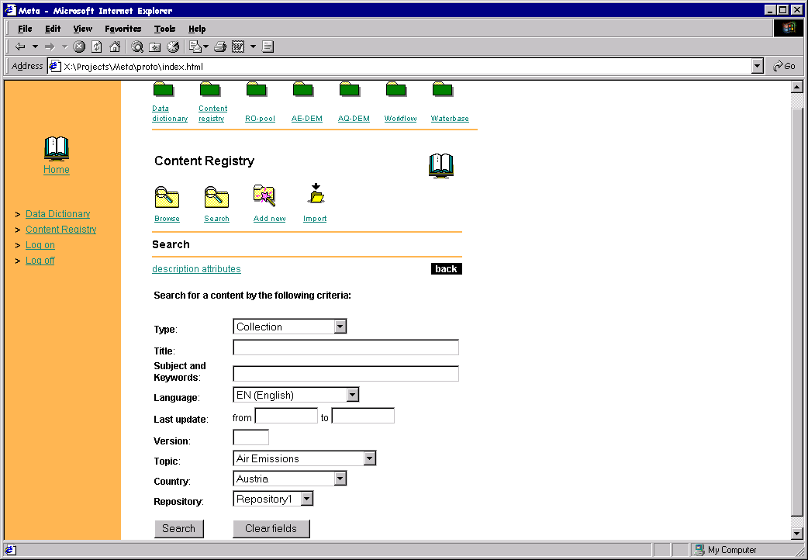

Figure 12. Searching view of the Content registry

How do you collect keywords from predefined lists (or from the data dictionary?)

Result set view (figure 13) presents the resulting list of the search, each element in the list representing a content description with its name, last update and link to the actual content itself in columns. In addition result set view opens access to three more functionalities:
- modify content descriptions
- delete selected content descriptions
- export selected content descriptions
Deleting and exporting functionalities are presented with the ability to mark one or several of the listed descriptions and press the buttons of either deletion or export of the marked descriptions.

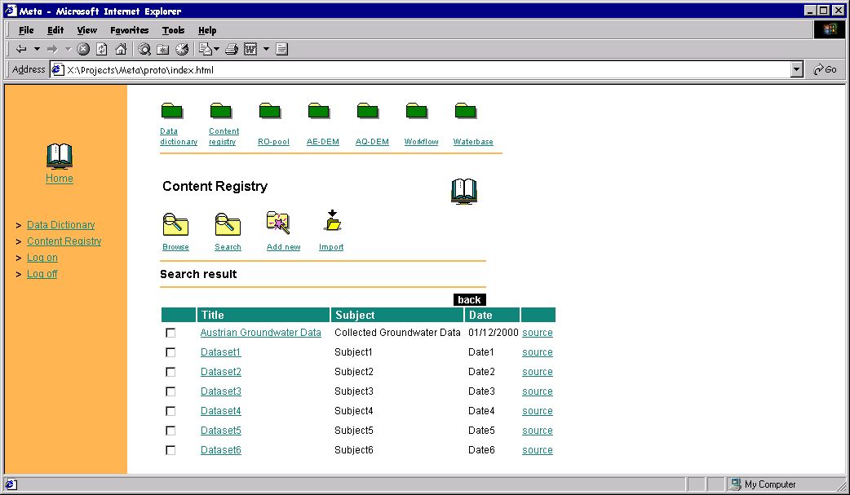
Figure 13. Result set view of the search in Content registry

Import view (figure 14) for the data dictionary enables users to import new data definitions in RDF format. For that, the import view enables to select the desired RDF file from a hard-disc and by submitting the selected schema file to the Content registry, it will be stored to the RDF repository and processed for gathering and saving meta-information into the database as well.
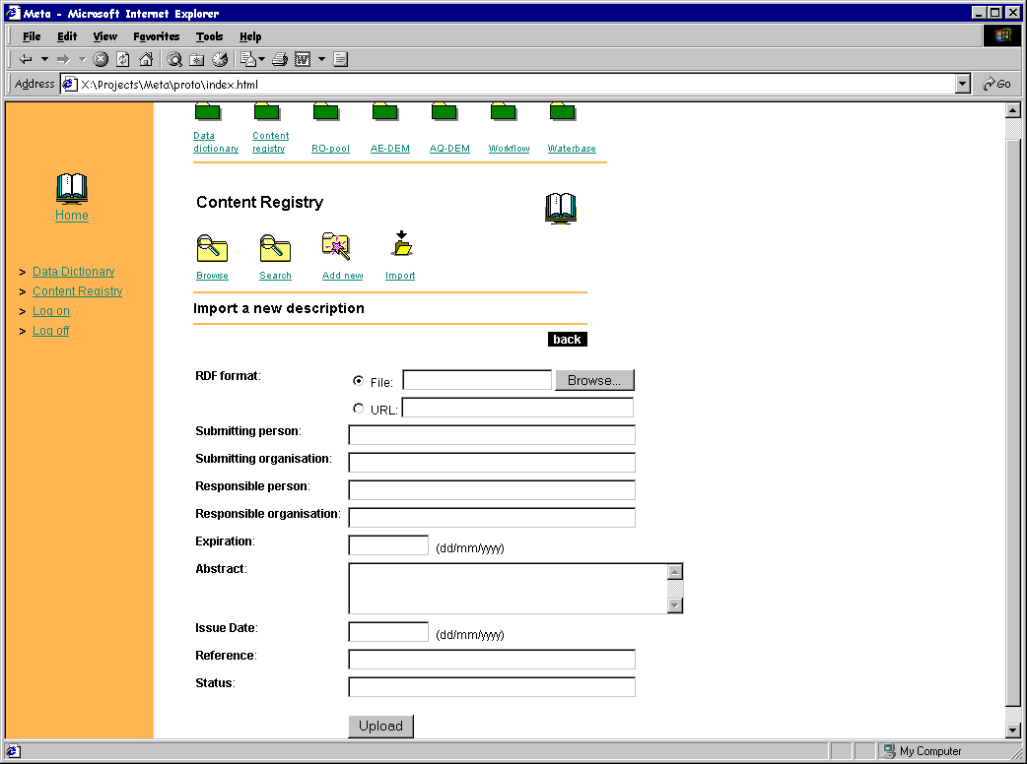
Note that importing view also requires specification of several administrative attributes from the user. The meaning and the origins of those attributes are more closely explained in chapters below.

Figure 14. Import view of the Content registry

Modifying view (figure 15) enables specification of several content description attributes but in addition to that it enables also to select an XML Schema for validating the currently modified content in case it happens to be an XML format content. For all other types of contents that selection will be ignored.
Modifying view is reached by pressing a content description’s link in the resulting list of the search.
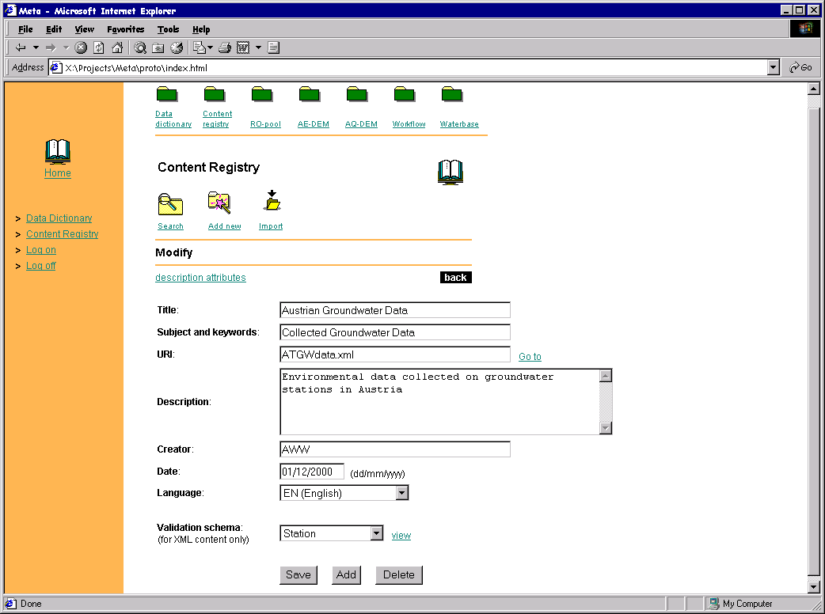

Figure 15. Modifying view of the Content registry

Adding new definition view is virtually the same as the above described modifying view, with the exception that the inputs will be left empty to be filled with new data. Therefore no explicit figures are given here for that functionality.

Deleting view and exporting view will be simply message boxes, indicating of the failure or success of the deletion or announcing of the start of the downloading process that will be initiated when selecting export of the selected descriptions. The latter means that the RDF formats corresponding to the selected descriptions will be packaged into one and prompted for the user to save them somewhere to a hard disc.

Administrative views

Administrative views are those common to modifying and adding functionalities of both subsystems and representing the ability and request for specifying several administrative attributes, before causing any changes in the contents of the dictionary or the registry. So before submitting any changes to the database and the XML (RDF) repositories, the system will ask for specification of administrative attributes that were already present in the importing views described above and whose meanings and origins are more thoroughly explained in the chapters below.
Administrative attributes view is displayed when clicking ‘Add’ or ‘Save’ buttons in the modifying or adding views of the two subsystems. It is given on figure 16a, on the basis of Data dictionary though the registry’s one differs only in titles.

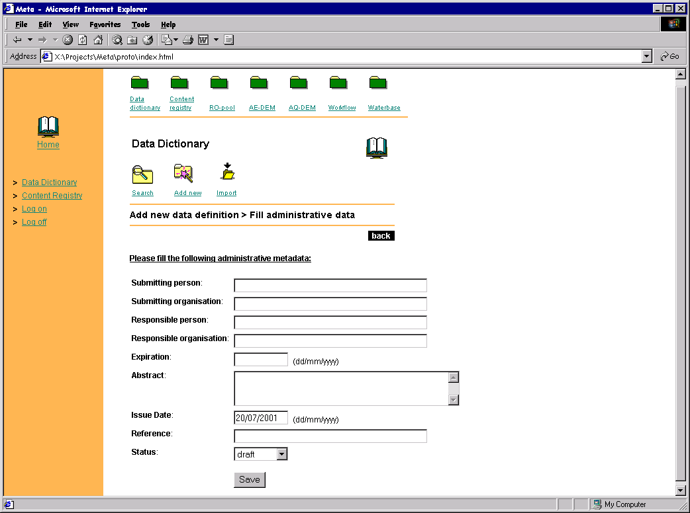
Figure 16a. Administrative attributes view of both subsystems.

Administrative attributes need to come from CIRCA, an interface needs to be provided and it needs to work.

Confirmation views

When a new data definition or content description is added or existing ones are modified, it would be good to provide user with a glimpse of the corresponding XML Schema or RDF description that was automatically generated to keep the databases and the schema repositories synchronized. That would also confirm (or deny) the success of the adding or modifying process. Such a possible confirmation view is given on figure 16b, where the upper part announces of a successful addition/update and the corresponding schema is displayed below.

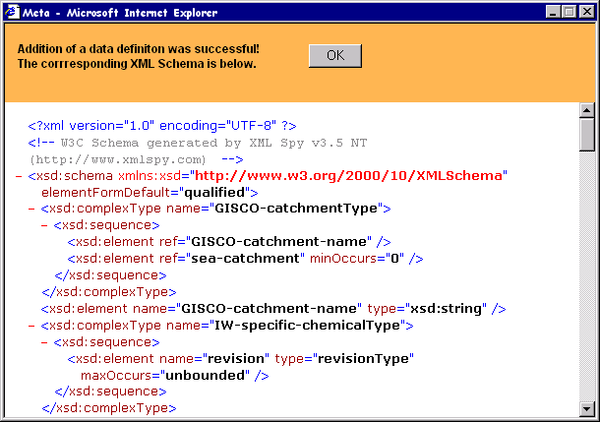
Figure 16b. Confirmation view of a successful addition/update

Data Model

Class diagram of the Data dictionary
The class diagram, given on the figure 17, serves as a general view of the main classes that could be identified in the conceptual view of the Data dictionary’s software. From that diagram, later on, a database model for the Data dictionary will be derived.

On the general level, classes of the Data dictionary’s software could be divided into three groups:

- Actors
- Concepts
- Events

Concepts serve as subjects to actions and events initiated by actors. They are abstractions of data definitons and they can be divided into Characteristics and Aggregates. Aggregates are aggregations of Characteristics and the latter, in turn, are aggregations of either Fixed value ranges or Unit-measured Value ranges, depending on the type of chracateristic.
The central point of the class diagram is the Data definition which realizes the concepts and encapsulates the definiton attributes (also regarded as definition fields). Data definition also aggregates the events that might be driven on it. Events are divided into three:

- Registration event
- Definition event
- Review event

Events are all of administrative nature and they are initiated by actors of two types: Data administrator and Reviewer. Both of the acotr types are abstractions of the Person class which encapsulates all the attributes necessary for identifying a person responsible for the event. Each person is thought to belong to an organisation and this is represented by an aggregate relation to Organisation class.

The following table gives short descriptions to the main classes in the described diagram:

Class | Description
Aggregate | The aggregate represents a set of related data elements whose characteristics define a single distict concept.  EIONET examples: station, indicator, pressure, chemical
Characteristic | This data element is a basic information element and independent from any specific context.  It identifies a single unit of data and its characteristics.  It may have two types of characteristics: value range with unit of measure and fixed value range.  EIONET examples: longitude,latitude,altitude,population,station type,  station size, ...
Fixed value range | Defines the fixed value range of a data element.  Obligation: conditional (mutually exclusive with Value range)
Value range | Defines the value range of a data element with units of measure.  Obligation: conditional (mutually exclusive with Fixed value range)
Data defintion | Data definition is the central class that defines a set of attributes common to the Aggregates and Characteristics
Registration event | This class represents the event when the system registers the data definitions and assigns identification number, version, and status.
Definiton event | This class represents the event when the data administrator manages the data definitions
Review event | This class represents the event when the data reviewer checks the data definitions
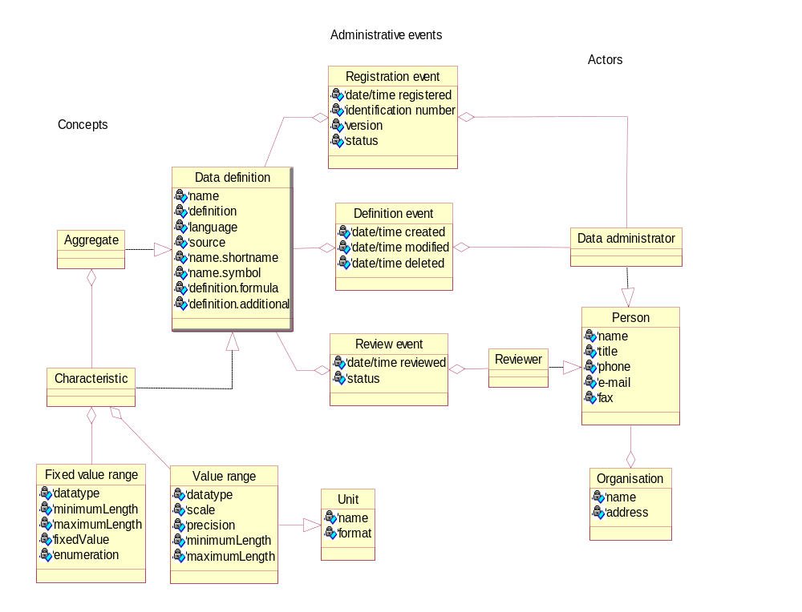

Figure 17. Class diagram of the Data dictionary’s application software

Database model of the Data dictionary
Data dictionary’s database model has been derived from the conceptual view represented in the above class diagram. It has been designed by keeping in mind the following guidelines:

- Database model should be as slightly complex as possible while still covering the identified classes and functionalities.
- Database model should be flexible enough to allow adding of new attributes to the data definitions so that the database structure will not have to be changed when new attributes will be discovered necessary.
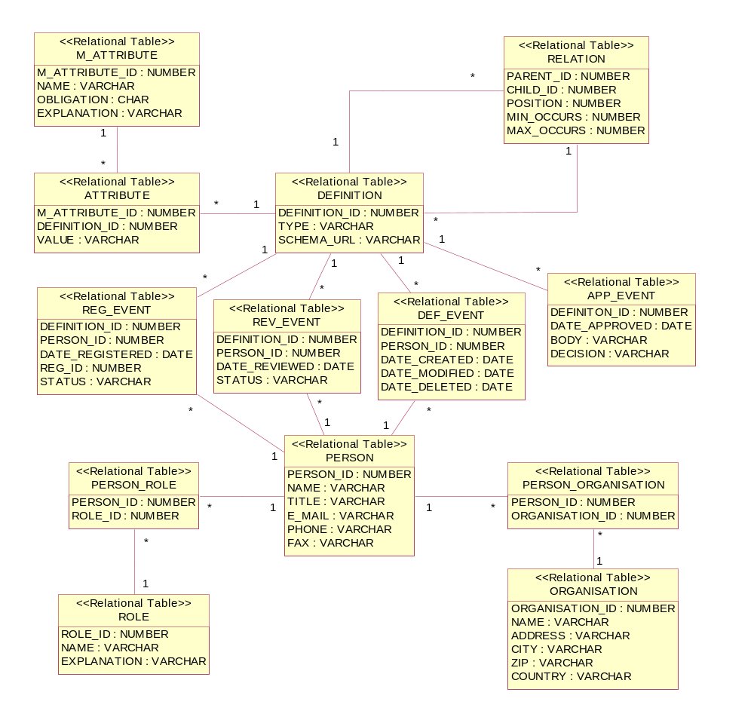
- Data dictionary’s database model should fully cover the subset of XML Schema specification that will become the scope of the XML Schema format data definitions. This means that all the definition specifics that might occur in the XML Schema format definition, must be enabled to be saved into the database as well. Because the schema repository and the dictionary’s database must be synchronized.

Figure 18. Database model of the Data dictionary

Some remarks to the database model, given on figure 18:

- The flexibility of allowing addition of new attributes to the data definitions so that the database structure does not have to become changed, is gained by the introduction of a meta-level table M_ATTRIBUTE whose rows will contain descriptions of what attributes might a definition have and what do they actually mean. The values of the attributes themselves will therefore be gathered into a separate table ATTRIBUTE where each row will be corresponding to an entry in the M_ATTRIBUTE table and to a definition in the DEFINITION table.
- The ability to define aggregate data elements and therefore to allow determination of sub-elements to an element, is gained by introducing a table called RELATION. Each entry in that table will represent a parent-to-child relation between two definitions, parent being an aggregate and child being a characteristic. Each relation also defines minimum and maximum allowed occurrences of child elements in a parent element and also the position where exactly the child element is placed in the set of child-elements. The latter is necessary, because data definitions in the database will also be stored in XML Schema format and the latter specifies that a set of sub-elements is strictly ordered.
- URLs to the XML Schemas corresponding to definitions are kept in the SCHEMA_URL field of the DEFINITION table.
- The administrative events, discussed more closely in the above chapter of class diagram, are covered by three tables, the names of which should be self-explanatory: REG_EVENT, REV_EVENT, DEF_EVENT. Each entry in the event tables is uniquely identified by the initiating person (see the PERSON table) of the event and the definition it belongs to.
- History of definitions’ approval events is kept in a table called APP_EVENT. A definition’s approval event is uniquely defined the date it was made, the body who approved and the decision taken. Note that, unlike other event tables, the approving body has no relation to the PERSON table, because it quite an abstract object that can be a person, a meeting, a committee, an organisation, etc. Therefore it is kept as simple text only.
- Each person has at least one role in the activities that can be performed in the Data dictionary. As a person can actually have several roles and roles may have several person attached to them, the many-to-many relationship is resolved by the PERSON_ROLE table.
- Each person also has to belong to at least on organisation. But as he/she can also belong to several organisations and organisations naturally have many people working there, the many-to-many relationship here is resolved by the PERSON_ORGANISATION table.
- Distinction between aggregate data elements, elements with fixed value range and elements with unit-measured values in the DEFINITON table entries is made with the TYPE field in that table. TYPE field indicate which of the three is the type for the current entries.
Attributes of Fixed value range and Value range classes in the class diagram are treated in the database just as any other attributes of a definition, described and valued correspondingly in the M_ATTRIBUTE and ATTRIBUTE tables.

Database model of the Content registry
As content descriptions are seen in mostly the same contexts (attributes, administrative events, ..) as data definitions, it turns out to be quite natural to use the same tables for representing those contexts both for the dictionary and the registry. Therefore database models of both systems will be integrated into one, sharing the tables of attributes and events and withholding the entries of content descriptions and data definitions and aggregate relations for the latter. So the table for content description entries is shown on Figure 19 and so are its relations to other tables already familiar from the above data model of data dictionary. That table is called DESCRIPTION and it has an identifying attribute and an attribute containing the URL to the XML format of a description. Other than that, all the relations to attribute tables and administrative events can be explained as it was done in the above case for the dictionary.
So the Meta system’s database model has actually two specific parts- one for the Data dictionary (Figure 18) and one for the Content registry (Figure 19)– and a common part for the common context surrounding the two subsystems. And by integrating the two named figures, we get the Meta system’s database model.
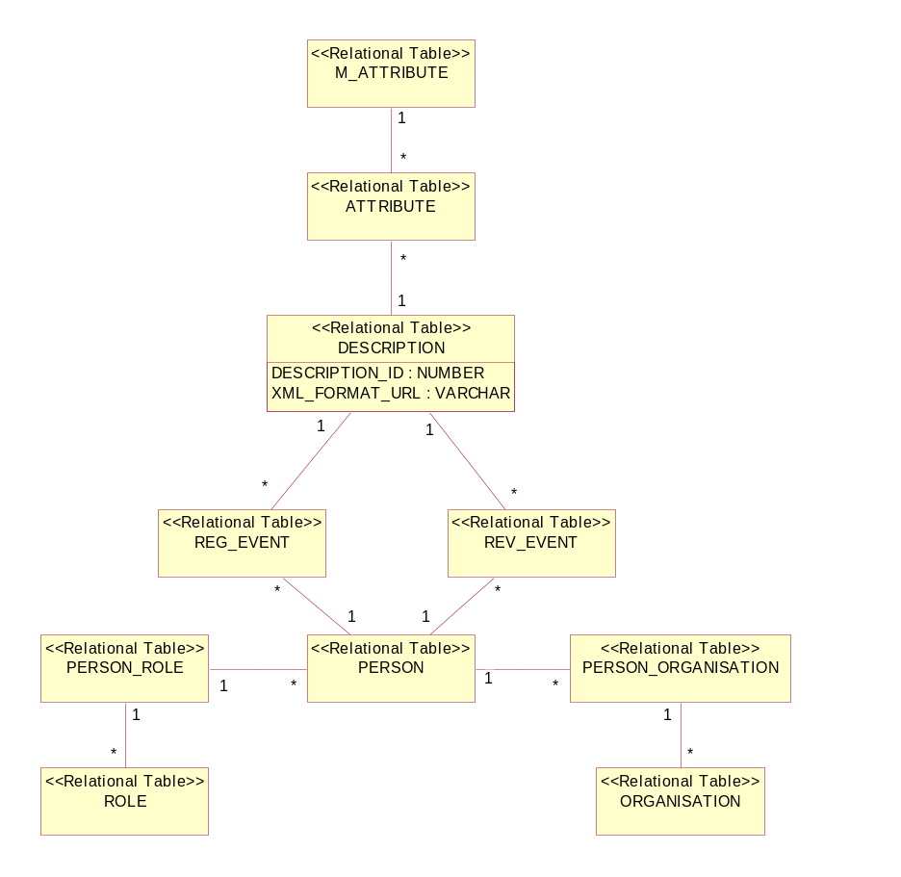

Figure 19. Database model of the Content registry

How do I determine that this database model is able to handle DCES and administrative metadata in CIRCA? Please help!

Architecture

3.1 Interfaces to the Metadata system
The figure 20 shows the preliminary design of components and interfaces of the proposed target system. Both the Data dictionary and Content registry are presented as individual tools of the same META architecture. Although the tools are separated, they will be implemented using the same XML server framework.
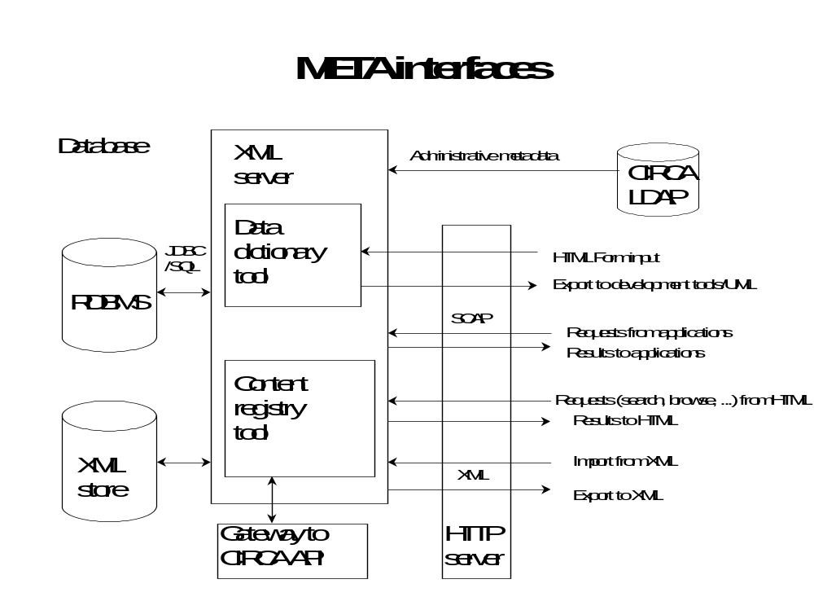
Figure 20. Proposed components and interfaces of the Metadata System

The following standard protocols will be supported:

- XML for import and export. XML Schema syntax for Data dictionary and RDF syntax for Content registry.
- SOAP for application-to-application protocol.
- LDAP for accessing administrative metadata in the Directory
- JDBC for accessing SQL database

3.2 System architecture
System architecture is the same both for the Data dictionary and the Content registry, therefore no clear distinction is made in this chapter between those two. It is presented on figure 21 and it consists of three main tiers:

- Presentation layer for providing the user interface
- Application layer (business logic) for implementing the META functionality
- Data layer for the META data

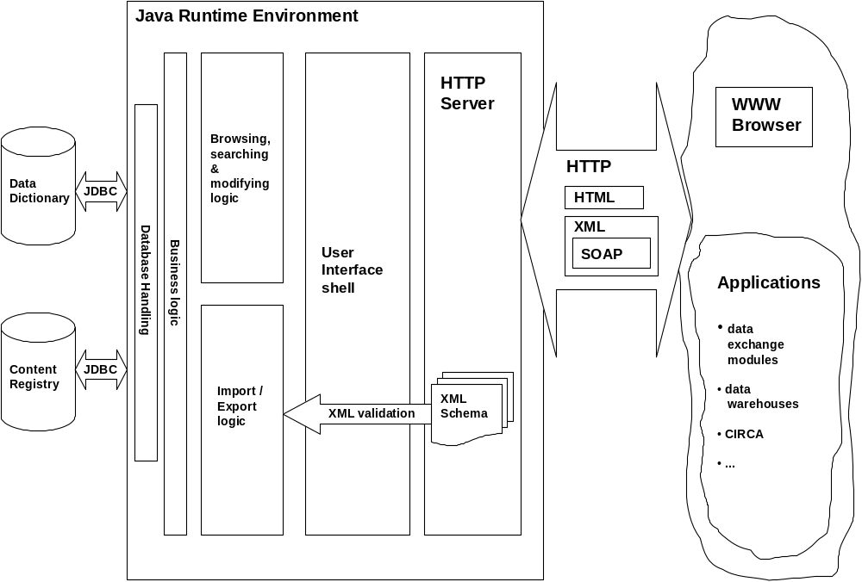

Figure 21. Preliminary system architecture of the Metadata Registry System

The above picture represents system architecture both for the Data dictionary and Content registry, as the difference is only in the database and therefore also in the user interface. All the apllication infrastructure around the databases follows similar technologies and principles.

The core part of the infrastructure is application software that will be written in Java programming language and therefore the whole application will run in Java Runtime Environment.

As for the communication basis between the Java code and the databases- it will be based on Java DataBase Connectivity (JDBC) driver.

Logically, the application software can be divided into 5 parts:

- Database handling logic- is responsible for performing the basic database operations, like SELECT, UPDATE, INSERT and DELETE operations.
- Business logic- is responsible for suiting and feeding the imported/updated data for the Database handling logic
- Browsing, searching and modifying logic – is responsible for mediating the user –or application input data between the user client or application and the Business logic.
- Import/Export logic – is responsible for parsing and extracting imported data from XML format and mediating it to the business logic. For the case of export, this logic generates XML format output for the user/application requesting the data.
- User interface shell – is responsible for performing, keeping and maintaining the communication between the browsing-, searching-, modifying-, importing -and exporting logic and clients interfaced with HTTP-based formats.

On the lowest level, HTTP Server handles communication means between the system and it’s clients whether they are humans with a WWW browser or applications providing HTTP based communication formats, like HTML, XML and SOAP based on the latter. As the HTTP Server will also have to provide Java servlets for the clients, it must have compatibility with a Java Servlet Running Engine supporting JSDK 2.2 (Java Servlet Development Kit) and it is going to run in Java Runtime Environment.

XML Schemas, representing the data definitions in the dictionary, will also be provided by the HTTP Server via URL interface. XML Schemas are also used for validating an XML document when such is to be imported or registered in the Content registry. The block arrow with a title of XML Validation serves for that.

Regarding the clients, they are generally divided into 2 groups:

- Humans as users – interfaced with system by WWW browsers
- Applications as users - interfaced with system by HTTP based formats, like HTML, XML and inter-application communication format SOAP (Simple Object Access Protocol).

Communication between Content registry and its client applications
Rather than a manually used interface, Content registry is going to be primarily a self-driven system, automatically communicating with client applications in the background. Human interaction is mainly of administrative nature only.

General solution

Content registry’s operating principals are going to be very much like those of the infamous music files retrieval system Napster. These principals are in general stated as follows:

- Based on configurable frequency or driven by certain events (like for example addition of a new repository), Content registry automatically searches for certain type of contents (reported data sets) with categorised data from distributed repositories within its searching scope and harvests the metadata (e.g. descriptions) of those contents.
- When a new content repository is added to the Content registry’s searching scope, descriptions of all the repository’s contents will be harvested.
- On a regular basis Content registry harvests the metadata of only the newly uploaded/updated contents. Therefore repositories must provide some kind of a searching criteria representing the time dimension (i.e. issue date, upload date, etc).
- Harvested metadata will be saved and kept in the Content registry’s database
- Through the registry’s user interface harvested metadata will be made accessible through a certain set of functionalities (browse, search).

I like this! It should be a generic as possible- open to other repositories!

We should also consider that the content registry might act as a broker between the clients described below and search interfaces to be built on top of them.

Figure 22 sketches the general event –and processing flow between the Content registry and applications providing content descriptions. When a new content repository is added to the registry’s searching scope or the searching frequency requires so, Content registry “goes out” looking for newly uploaded/updated contents by sending a corresponding query separately to each of the repositories in its searching scope. The communicating mechanism on the repository’s side could be anything capable of receiving and understanding HTTP requests and sending HTTP responses naturally back to the requesting side. That’s because HTTP is going to be the mandatory communication protocol for all the repositories. Such communication mechanisms could be for example CGI or Servelts in a simplest case or some kind of HTTP-aware wrappers around the repository’s API in a little more complex case (like CIRCA for example).

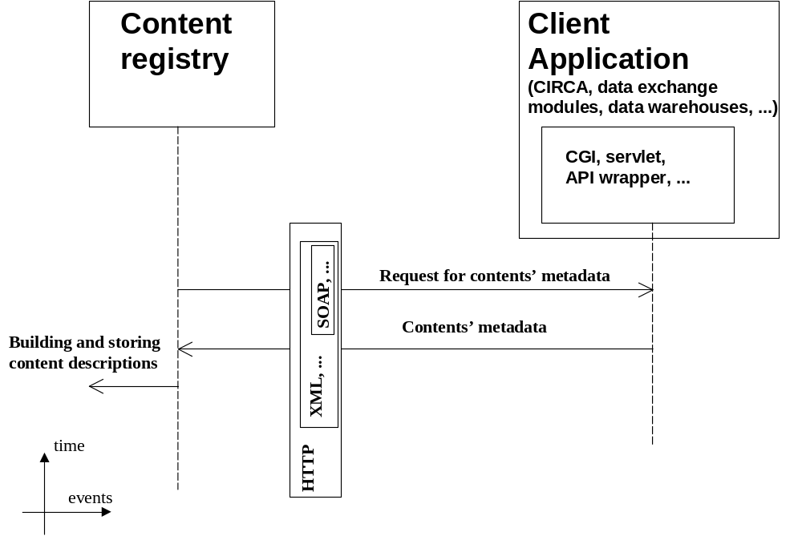

Figure 22. Event –and processing flow between the Content registry
and its client applications

Concrete solutions - CIRCA

A concrete solution would be for example CIRCA where there are currently plans to have an HTTP-aware wrapper around the systems API and the communication format would be SOAP as basically the only way to send API calls on XML on top of HTTP.

The META view: CIRCA as content repository

add delivery process in general
- Delivery is a collection of datasets.
- Datasets are uploaded to the CIRCA library.
- The structure and naming conventions of the library will be specified in the Repository project.
- The workflow related to the delivery will be specified in the Workflow project.

The Metadata description has to updated in the library ?! How is the communication between the current CIRCA metadata input window and META dictionary / registry?! Will the META application be opened once data is uploaded?

From the META point of view:
- Each dataset is associated with two metadata files: content description and content schema.
- Content description contains the business metadata of the whole dataset.
- Content schema describes each individual data item in the dataset and their structure.
- The content descriptions will follow Dublin Core standard and will be presented in RDF.
- The content schema will follow ISO11179 standard and will be presented in XML Schema.
- the tasks related to content management are description, upload and search.

Good, interesting

Content management tasks

The description task takes place either before the upload process or as a sub-process of upload:
- user fills a form for the content description metadata. To help the user: a) The system generates a choice list so that user can choose among the data elements what is contained in the dataset. This list of elements is based on the content schema. b) The system provides possibility to link to obligations, relevant page(s) in ROD.
- So, we also open the WebROD in there – but the application needs to be modified quite a bit.
- the system generates RDF from the user input and stores it into the Repository.

The upload task:
- user uploads the dataset into the Repository
- user either uploads the content description into the Repository or calls the content description process
- creates a link to a schema that is already stored in the Repository or in the META schema store.
- the system validates the dataset (if in XML) and informs user about the results.

The search task:
- The Content Registry harvests the Repositories and fetches the content descriptions (RDF files). Harvesting takes place at least once a day.
- The Content Registry generates an index and a catalogue of content descriptions.
- User can search the index for free text.
- User can browse the catalogue according to different categories (country/topic/sub-topic/parameter/...)

Possible solutions using CIRCA Library as Repository

- The description and upload as combined task:

In this solution the content description task is part of upload task. The CIRCA system provides the form, and choice lists for the user interface and stores the metadata attributes in it's internal format.

The CIRCA system allows the user to link to the content schema and validate the content of the dataset, if it's in XML.

The CIRCA system informs a user about the results of validation.

The META Content registry accesses the metadata through the CIRCA_API and generates RDF file and uploads it into the CIRCA Library.

- Separated description and upload tasks:

In this solution the description and upload are separated tasks.

If the description task takes place before upload, the dataset and it's RDF file are uploaded into the CIRCA Library at the same time.

If the description task takes place during upload, the CIRCA system calls an external module that provides the form and choice lists for the user interface and uploads the metadata as RDF file into the CIRCA Library using CIRCA_API.

The CIRCA system calls an external module that allows the user to link to the content schema and validate the content of the dataset, if it's in XML. The external module informs a user about the results of validation.

- Search task:

The Content Registry harvester accesses the CIRCA Library using CIRCA_API. It traverses the tree structure of the library and fetches all new/modified RDF files.

The Content registry generates free text index of the RDF files.
How does this look like?

The Content registry categorises the content of the RDF files using an existing taxonomy. This information is stored in the Content Registry catalogue.
Which taxonomy?

The Content registry provides a user interface both to the index and to the catalogue.

3.3.2.4 CIRCA integration

CIRCA version 2.2 has an application programming interface that is described in the document CIRCA – Application Programming Interface – Version 1.0 - Draft [CIRCA-API-Programming-doc-010.pdf].

Is this still the valid CIRCA API docu? Don’t we have better in 2.5 / 2.6 ?

According to the document:
- The present document describes the CIRCA API developed to provide a unified, simple, friendly, though complete and accurate mechanism for fully manipulating the structure of a given (virtual) CIRCA through a Unix account that resides on the same system where the CIRCA installation exists.
- The developed interface is designed to shelter the user from any underlying intricacies, by also retaining the simplicity and robustness sought.

This API can be used to access the CIRCA document library for retrieving document metadata. It can also be used to search for new, deleted, or modified documents. The API can be thus considered from the META point of view as single point of access to CIRCA. The benefit is simple architecture and definition of roles between the vendors: TietoEnator and European Dynamics.

3.3.2.5 The architecture

The proposed architecture:
- The integration architecture is server-to-server between XML server (Java) and CIRCA server (Perl).
- SOAP is used as protocol
- The XML server sends API calls (e.g show_circas, show_attrs) as SOAP requests to the CIRCA server.
- CIRCA server returns data objects as either Perl simple arrays (@) or associative arrays (%). Since SOAP specification is not yet final and the interoperability of different datatypes is not formally specified, it's recommended that these data types are transformed to XML and serialized as String.
- This XML representation of CIRCA metadata is transformed to RDF using XSLT (XML transformations) in the XML server.

3.3.2.6 Interoperability

The proposed architecture is generic so that it can fetch metadata from any content repository if the following requirements are met:
- the repository has public API for accessing the document metadata.
- the repository has a SOAP interface that is able to transform the metadata to XML
- the metadata attributes can be transformed to simple XML format, for example
<attr key="metadata attribute name">metadata attribute value</attr>
- the namespace of these metadata attributes must follow the Dublin Core namespace or there must exist a mapping between the namespaces.
- the META content registry transforms the XML to generic RDF using per-defined transformation rules.

We shall look at the RDF thing – if we can really do it or if it is too complex.

3.3.2.7 The prototype

The purpose of the proto is demonstrate the possibility to fetch metadata of a document in the CIRCA library and transform the metadata to RDF format.

- The CIRCA SOAP server proto is based on SOAP::Lite and it's implemented as simple stand-alone HTTP Daemon on the Unix where the CIRCA 2.5 installation resides.
- The CIRCA SOAP server provides a wrapper around the CIRCA API: each API call is implemented as a SOAP method.
- The CIRCA SOAP server formats the objects to XML and the resulting XML fragment is serialized as String.
- The XML server deserializes the objects to XML and performs the XML transformation.

An example of an XML representation of a CIRCA document attributes returned by show_attr in an associative array %attrs.

<attrs>
<attr key="FILENAME">CIRCLE-REQ-050.doc</attr>
<attr key="TYPE">application/msword</attr>
<attr key="TITLE">CIRCA 2.5e spec</attr>
<attr key="AUTHOR">Startup User</attr>
<attr key="UPLOADDATE">06/04/2001</attr>
<attr key="EXPIRATION"/>
<attr key="ABSTRACT"/>
<attr key="STATUS">Draft</attr>
<attr key="LANGUAGE">EN</attr>
<attr key="VERSION">1.0</attr>
<attr key="ISSUEDATE">06/04/2001</attr>
<attr key="KEYWORDS"/>
<attr key="SIZE">227840</attr>
<attr key="OWNER">gandalf</attr>
<attr key="REFERENCE"/>
</attrs>

From the META point of view these attributes represent more technical metadata than content description. The Content Registry can use this metadata to locate datasets and keep track of the changes.

An example of Java code needed to fetch this XML fragment:

public static final String DEFAULT_SERVICE_URL = "http://troll.eionet.eu.int:8010/";

String serviceURL = null;

serviceURL = DEFAULT_SERVICE_URL;
URL url = new URL(serviceURL);

SOAPHTTPConnection st = new SOAPHTTPConnection();

// define deserializers for the return things (without xsi:type)
SOAPMappingRegistry smr = new SOAPMappingRegistry ();
StringDeserializer sd = new StringDeserializer ();
smr.mapTypes (Constants.NS_URI_SOAP_ENC,
new QName ("", "attrs"), null, null, sd);

//RPC Call
Call call = new Call();
call.setSOAPTransport(st);
call.setTargetObjectURI("CIRCAProto");
call.setMethodName("show_attrs");
call.setEncodingStyleURI(Constants.NS_URI_SOAP_ENC);
call.setSOAPMappingRegistry (smr);

Vector params = new Vector();
params.addElement(new Parameter("circa", String.class,
"ringlord", null));
params.addElement(new Parameter("ig", String.class,
"test25e", null));
params.addElement(new Parameter("section", String.class,
"requirements", null));
params.addElement(new Parameter("pool", String.class,
"circle_req_050_doc", null));
params.addElement(new Parameter("lang", String.class,
"EN", null));
params.addElement(new Parameter("ver", String.class,
"1.0", null));
call.setParams(params);
Response resp;

try {
resp = call.invoke(url, null);
} catch(SOAPException e) {
e.printStackTrace();
}

// check response
if (! resp.generatedFault()) {
Parameter retval = resp.getReturnValue();
Object value = retval.getValue();
} else {
Fault fault = resp.getFault();
}

3.4 Communication between Data dictionary and its client applications
To take a full effect, Data dictionary must, besides sharing its data definitions to users, also enable usage of its contents to different kinds of client applications that might be in need of them. Such applications could be for example all kinds of national repositories where the process of uploading or updating of a reported dataset might need XML Schema format data definitions for the reported data. In such a case Data dictionary must enable request and provision of lists of available data definitions and exchange formats.
Unless explicitly required otherwise, a common technical solution for such an information exchange is presented in the following sub-chapter, on Figure 24.

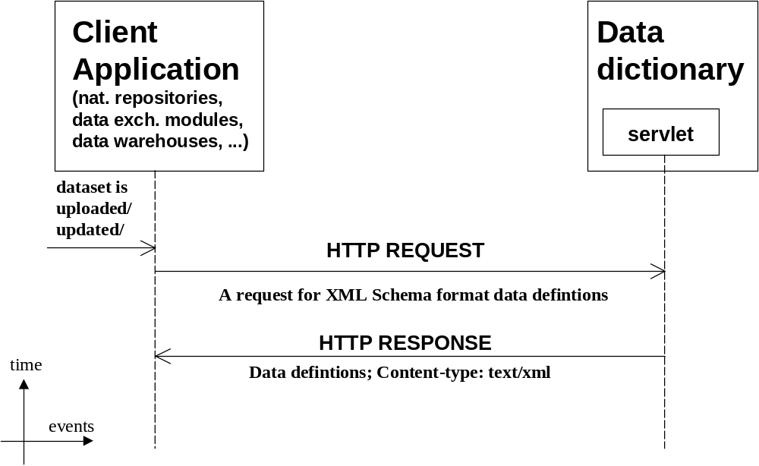
Figure 24. Data definitions exchange from Data dictionary to clients

Figure 24 illustrates an event-flow where the initiating upload/update of some kind of a dataset or collection in some kind of a client application triggers an HTTP request sent to the Data dictionary and containing the need for a certain set of XML Schemas format data definitions. HTTP request is processed by a servlet which has an output content type of text/xml and sends the retrieved schema(s) back the requesting side.

XML Schema format data definitions

According to the user requirements the data definitions will be kept both as operational data in the Data dictionary’s database and in XML Schema format in the schema repository. Naturally, both of these storages have to be synchronized. This means that when a new XML Schema format definition is uploaded, it should be processed so that all the metadata it contains will be gathered and saved to the database. And vice versa- when a new definition is added through a web-form, a corresponding XML Schema should be generated and stored into the schema repository.
The above requirements demand that the functionality of the web-form for adding a new defintion should be complex enough to enable creation of a corresponding XML Schema. But as the XML Schema specification is quite huge and the project’s purpose is not developing an advanced graphical XML Schema creator, only a certain subset of XML Schema specification should be covered by the schema format definitions. The same need comes also from uploading definitions explicitly in schema format, because those defintions will have to be simple enough to allow displaying and editing all of a definition’s metadata in a web-form.
The following chapters propose a certain subset of XML Schema specifications that should cover all the data definitions’ metadata needs while still maintaining reasonable abiltiy of modifying through a web-form.

4.1 XML representation of ISO 11179 attributes
Name of attribute | Definition | Obligation
1. Identifying attributes
- Name | Single or multi word designation assigned to a data element. | M
- Identifier | A language independent unique identifier of a data element within a Registration authority. | M
- Version | Identification of an issue of a data element specification in a series of evolving data element specifications within the Registration authority. | M
- Registration authority | Any organisation authorised to register data elements. | C
- Synonymous name | Single word or multi word designation that is different from the given name, but represents the same data element concept. | O
- Context | A designation or description of the application environment or discipline in which a name and/or synonymous name is applied or originates from | C
2. Definitional attributes
- Definition | Statement that expresses the essential nature of a data element and permits its differentiation from all other data elements. | M
3. Relational attributes
- Classification scheme | A reference to (a) class(es) of a scheme for the arrangement or division of objects into groups based on characteristics which the objects have in common. | O
- Keyword(s) | One or more significant words used for retrieval of data elements | O
- Related data reference | A reference between the data element and any related data. | O
- Type of relationship | An expression that characterises the relationship between the data element and related data. | C
4. Representational attributes
- Representation category | Type of symbol, character or other designation used to represent a data. | M
- Form of representation | Name or description of the form of representation for the data element, e.g. quantitative value, code, text, icon, ... | M
- Data type of data element values | A set of distinct values for representing the data element value. | M
- Maximum size of data element values | The maximum number of storage units to represent the data element value. | M
- Minimum size of data element values | The minimum number of storage units to represent the data element value. | M
- Layout of representation | The layout of characters in data element values expressed by a character string representation. | C
- Permissible data element values | The set of representations of permissible instances of the data element, according to the representation form, layout, datatype and maximum and minimum size specified in the corresponding attributes. The set can be specified by name, by reference to a source, by enumeration of the representation of the instances, or by rules for generating the instances. | M
5. Administrative attributes
- Responsible organisation | The organisation responsible for the contents of the mandatory attributes by which the data element is specified. | M
- Registration status | A designation of the position in the registration life-cycle of a data element. | C
- Submitting organisation | The organisation that has submitted the data element for addition, change or cancellation. | O
- Comments | Remarks on the data element. | O

Obligation: M = mandatory, O = optional, C = conditional

4.1.1 Name
- add naming conventions

<xsd:element name="name"/>

4.1.2 Identifier
- condition: If the attribute 'Name' is not unique within a Registration authority this attribute is mandatory.

<xsd:element id="identifier"/>

4.1.3 Version

<xsd:annotation>
<xsd:documentation xml:lang="en">
<xhtml:tr>
<xhtml:th>Version</xhtml:th>
<xhtml:th>version number</xhtml:th>
</xhtml:tr>
</xsd:documentation>
</xsd:annotation>

4.1.4 Registration authority

ISO11179 | ReportNet implementation
Condition: One registration authority shall be specified for each Identifier present.  Comments:  a) The combined attributes 'Registration authority', 'Identifier' and 'Version' serve to uniquely identify a data element.  b) A data element may be registered by multiple Registration authorities. | Each Registration authority is represented as code that is for usually it's abbreviated name, for example EEA for European Environment Agency, TE for TietoEnator, ...  The full name of the Registration authority may be given as optional information.  The unique identifier of a data element is of the form:  {registration_authority_code}{identifier}v{version}  For example: EEA1234v1, TE100v0.1  The unique identifier is used also as filename of the definition of the data element. The filename extension is 'xsd' (XML Schema).  For example: EEA1234v1.xsd, TE100v01.xsd

<xsd:annotation>
<xsd:documentation xml:lang="en">
<xhtml:tr>
<xhtml:th>Registration authority</xhtml:th>
<xhtml:th>Registration authority code </xhtml:th>
<xhtml:th>Registration authority full name </xhtml:th>
</xhtml:tr>
</xsd:documentation>
</xsd:annotation>

4.1.5 and 4.1.6 Synonymous name and Context

ISO11179 | ReportNet implementation
Synonymous names are often familiar names in a certain application environment. The 'Context' attribute is used to specify the context.  If more synonymous names occur this attribute and 'Context' shall be specified as pair.  Condition: 'Context' attribute is mandatory for each occurrence of the attribute 'Synonymous name'.  'Context' attribute is mandatory when the attribute 'Name' occurs in an information exchange.  Assignment of the attribute 'Context' to the attribute 'Name' may made mandatory as part of the procedures of any Registration authority. | Synonymous designation is specified as pair of attributes 'Name' and 'Definition'.  The data element may have several synonymous names.  Name, definition, and context are presented in a table where the first row contains the values of 'Name' and 'Definition' attributes of the current data element .

<xsd:annotation>
<xsd:documentation xml:lang="en">
<xhtml:caption> Synonymous names </xhtml:caption>
<xhtml:tr>
<xhtml:th> Name </xhtml:th>
<xhtml:th> Definition </xhtml:th>
<xhtml:th> Context </xhtml:th>
</xhtml:tr>
<xhtml:tr>
<xhtml:th> Name of this data element </xhtml:th>
<xhtml:th> Definition of this data element</xhtml:th>
<xhtml:th> Context </xhtml:th>
</xhtml:tr>
<xhtml:tr>
<xhtml:th> Synonymous name 1 </xhtml:th>
<xhtml:th> Definition 1</xhtml:th>
<xhtml:th> Context 1 </xhtml:th>
</xhtml:tr>
<xhtml:tr>
<xhtml:th> Synonymous name 2 </xhtml:th>
<xhtml:th> Definition 2</xhtml:th>
<xhtml:th> Context 2 </xhtml:th>
</xhtml:tr>
</xsd:documentation>
</xsd:annotation>

4.1.7 Definition

<xsd:annotation>
<xsd:documentation xml:lang="en">
<xhtml:tr>
<xhtml:th>Definition</xhtml:th>
<xhtml:th>Text </xhtml:th>
</xhtml:tr>
</xsd:documentation>
</xsd:annotation>

4.1.8 Classification scheme

ISO11179 | ReportNet implementation
Classification schemes can be used to relate data elements to functional, and/or organisational and/or technical classification schemes and/or conceptual models.  Example: For data element 'weight of body of resistor' the following classification schemes and classes thereof are valid:  IEC Data element type class: 'mass'  IEC Component class: 'electronic/electric component' | The classification scheme can be used for identifying and referencing the data element.  The value of this attribute is represented as pair: name of classification scheme and value(s) of classification scheme item(s)  This attribute can occur several times

<xsd:annotation>
<xsd:documentation xml:lang="en">
<xhtml:caption>Classification scheme(s)</xhtml:caption>
<xhtml:tr>
<xhtml:th> Name </xhtml:th>
<xhtml:th> Items(s) </xhtml:th>
</xhtml:tr>
<xhtml:tr>
<xhtml:th> Name of the classification scheme 1 </xhtml:th>
<xhtml:th> Classification scheme items(s)</xhtml:th>
</xhtml:tr>
<xhtml:tr>
<xhtml:th> Name of the classification scheme 2 </xhtml:th>
<xhtml:th> Classification scheme items(s)</xhtml:th>
</xhtml:tr>
...
</xsd:documentation>
</xsd:annotation>

4.1.9 Keyword

ISO11179 | ReportNet implementation
This attribute can be used for recording keywords (search keys) associated with the data element in question. | The keywords are presented as comma separated list

<xsd:annotation>
<xsd:documentation xml:lang="en">
<xhtml:tr>
<xhtml:th>Keywords</xhtml:th>
<xhtml:th>List of keywords </xhtml:th>
</xhtml:tr>
</xsd:documentation>
</xsd:annotation>

4.1.10 Related data reference and Type of relationship

ISO11179 | ReportNet implementation
When the related data is controlled by another Registration authority, the reference shall be a unique identifier, e.g. comprise the Registration authority and identifier of the referred data as allocated by it's Registration authority.  A data management environment shall set rules for applying this attribute.  If this attribute occurs it shall be specified in pair with the attribute 'Type of relationship'.  Examples of type of relationships are: qualifier of, qualified by, subject of, part of, physical condition, external reference, higher standard, data element concept. | The value of 'Relation' attribute is a pair of 'URI of a related data element reference' and 'Name of a related data element reference'.  DCMI specifies the 'Type of relationship' keywords:  Is Version Of  Has Version  Is Replaced By  Replaces  Is Required By  Requires  Is Part Of  Has Part  Is Referenced By  References  Is Format Of  Has Format  This pair of attributes can occur several times

<xsd:annotation>
<xsd:documentation xml:lang="en">
<xhtml:caption>Relation</xhtml:caption>
<xhtml:tr>
<xhtml:th> Related data reference </xhtml:th>
<xhtml:th> Type of relation </xhtml:th>
</xhtml:tr>
<xhtml:tr>
<xhtml:th>
<xhtml:a href="URI1"> Name of related data reference 1</xhtml:a>
</xhtml:th>
<xhtml:th> Type of relation 1</xhtml:th>
</xhtml:tr>
<xhtml:tr>
<xhtml:th>
<xhtml:a href="URI2"> Name of related data reference 2</xhtml:a>
</xhtml:th>
<xhtml:th> Type of relation 2</xhtml:th>
</xhtml:tr>
...
</xsd:documentation>
</xsd:annotation>

4.1.11 Representation category

ISO11179 | ReportNet implementation
The representation category shall be specified by the relevant standard e.g. ISO 646, EIA 556  Examples of this attribute:  character representation  character/symbol representation  bar coded representation  graphical representation | Always character representation (in XML)  The character encoding according to standard: Unicode UTF-8/ UTF-16/ ?  Must be the same for each elementary definition (fragment of XML).  This is a system parameter, and it cannot be changed by users.

<?xml version="1.0" encoding="UTF-8"?>

4.1.12 Form of representation and 4.1.13 Datatype of element values

ISO11179 | ReportNet implementation
The name or description should follow some classification scheme.  Examples:  - Data element name = "country of origin code" => For of representation attribute = "code"  - Data element name = "product description" => For of representation = "text"  - Data element name = "weight of consignment" => For of representation = "quantitative value"  Examples of datatype: 'character', ordinal number', 'integer', 'real', 'scaled', 'bit', 'rational' | The attributes 'form of representation' and 'datatype' are related.  For "Aggregate data elements" 'Form of representation' attribute is "aggregate".  For "Data elements with values measured in units" 'Form of representation' attribute is "quantitative value".  For "Data elements with fixed value range" 'Form of representation' attribute can be either "text", "code", "number" or "time".  For "Units" 'Form of representation' attribute is "unit".  If Form of representation attribute is "text" then "datatype" attribute is string or uriReference.  If Form of representation attribute is "number" then "datatype" attribute is decimal, float, double, boolean or binary.  If Form of representation attribute is "time" then "datatype" attribute is either timeInstant or timePeriod.

- [Definition:] timeInstant represents a specific instant of time. The value space of timeInstant is the space of Combinations of date and time of day values as defined in § 5.4 of [ISO 8601].
- [Definition:] timePeriod represents a specific period of time with a given start and end. The value space of timePeriod is the value space of Periods of time as defined in § 5.5 of [ISO 8601].
- The built-in primitive types of XML schema = string, boolean, float, double, decimal, timeInstant, timePeriod, binary, uriReference. The values of data elements should be based primarily on these types .
- Users can provide their own datatypes based on the primitive types
- Each data element has a datatype either implicitly derived from "unit" or explicitly defined by a user.

XML Representation for Aggregate data elements:

<xsd:element name="{name of aggregate element}">
<xsd:annotation>
<xsd:documentation>{Identifying attributes 1.3 -1.6}</xsd:documentation>
<xsd:documentation>{Definitional attribute 2.1}</xsd:documentation>
<xsd:documentation>{Relational attributes 3.1-3.4}</xsd:documentation>
<xsd:documentation>
<xhtml:tr>
<xhtml:th>Form of representation</xhtml:th>
<xhtml:th>Aggregate</xhtml:th>
</xhtml:tr>
</xsd:documentation>
</xsd:annotation>
<xsd:complexType>
<xsd:sequence>
<xsd:element ref="{name of aggregate_element}"/>
<xsd:element ref="{name of element_with_fixed_values}"/>
<xsd:element ref="{name of element_with_values_measured_in_units}" />
...
</xsd:sequence>
</xsd:complexType>
</xsd:element>

XML Representation for Data elements with values measured in units:
- principle is to derive a new type from the simple type based on 'unit'

<xsd:element name="{name of element_with_values_measured_in_units}" type="{unit}">
<xsd:annotation>
<xsd:documentation>{Identifying attributes 1.3 -1.6}</xsd:documentation>
<xsd:documentation>{Definitional attribute 2.1}</xsd:documentation>
<xsd:documentation>{Relational attributes 3.1-3.4}</xsd:documentation>
<xsd:documentation>
<xhtml:tr>
<xhtml:th>Form of representation</xhtml:th>
<xhtml:th>Quantitative value</xhtml:th>
</xhtml:tr>
<xhtml:tr>
<xhtml:th>Unit</xhtml:th>
<xhtml:th>{unit}</xhtml:th>
</xhtml:tr>
</xsd:documentation>
</xsd:annotation>
</xsd:element>

XML Representation for Data elements with fixed value range:

Case 1: Form of representation = Text or Code

<xsd:element name="{name of element_with_fixed_values}">
<xsd:annotation>
<xsd:documentation>{Identifying attributes 1.3 -1.6}</xsd:documentation>
<xsd:documentation>{Definitional attribute 2.1}</xsd:documentation>
<xsd:documentation>{Relational attributes 3.1-3.4}</xsd:documentation>
<xsd:documentation>
<xhtml:tr>
<xhtml:th>Form of representation</xhtml:th>
<xhtml:th>Text</xhtml:th>
</xhtml:tr>
<xhtml:tr>
<xhtml:th>Datatype</xhtml:th>
<xhtml:th>String</xhtml:th>
</xhtml:tr>
</xsd:documentation>
</xsd:annotation>
<xsd:simpleType>
<xsd:restriction base="xsd:string">
... Representational attributes 4.4 - 4.7 ...
</xsd:restriction>
</xsd:simpleType>
</xsd:element>

Case 2: Form of representation = Time.
- To add:
- special case: form of representation = date and/or time
- special case: form of representation = time instant (timestamp)
- special case: form of representation = period of time (with start and end time)
- special case: form of representation = duration of time (in units of time)
- special case: form of representation = recurring time

<xsd:element name="{name of element_with_fixed_values}">
<xsd:annotation>
<xsd:documentation>{Identifying attributes 1.3 -1.6}</xsd:documentation>
<xsd:documentation>{Definitional attribute 2.1}</xsd:documentation>
<xsd:documentation>{Relational attributes 3.1-3.4}</xsd:documentation>
<xsd:documentation>
<xhtml:tr>
<xhtml:th>Form of representation</xhtml:th>
<xhtml:th>Time</xhtml:th>
</xhtml:tr>
<xhtml:tr>
<xhtml:th>Datatype</xhtml:th>
<xhtml:th>{datatype}</xhtml:th>
</xhtml:tr>
</xsd:documentation>
</xsd:annotation>
<xsd:simpleType>
<xsd:restriction base="xsd:{datatype}">
... Representational attributes 4.4 - 4.7 ...
</xsd:restriction>
</xsd:simpleType>
</xsd:element>

Case3: Form of representation = Number.

<xsd:element name="{name of element_with_fixed_values}">
<xsd:annotation>
<xsd:documentation>{Identifying attributes 1.3 -1.6}</xsd:documentation>
<xsd:documentation>{Definitional attribute 2.1}</xsd:documentation>
<xsd:documentation>{Relational attributes 3.1-3.4}</xsd:documentation>
<xsd:documentation>
<xhtml:tr>
<xhtml:th>Form of representation</xhtml:th>
<xhtml:th>Number</xhtml:th>
</xhtml:tr>
<xhtml:tr>
<xhtml:th>Datatype</xhtml:th>
<xhtml:th>{datatype}</xhtml:th>
</xhtml:tr>
</xsd:documentation>
</xsd:annotation>
<xsd:simpleType>
<xsd:restriction base="xsd:{datatype}">
... Representational attributes 4.4 - 4.7 ...
</xsd:restriction>
</xsd:simpleType>
</xsd:element>

4.1.14 and 4.1.15 Maximum and minimum size of data element values

ISO11179 | ReportNet implementation
Example 1:  For data element 'invoice number' the attribute 'datatype' has instance 'character' and the attribute 'maximum size of data element value' has value '17'. The data element value of 'invoice number' shall have a maximum of 17 characters.  Example 2:  For data element 'product description' the attribute 'datatype' has instance 'character' and the attribute 'minimum size of data element value' has value '10'. The data element value of 'product description' shall have a minimum of 10 characters.  Example 3:  The two attributes 'maximum and minimum size of data element values' indicate whether data element values are 'fixed' (maximum and minimum values are equal or 'variable' (maximum and minimum size vary). | Maximum and minimum size attributes are related to database table definitions.  They can be used for to automatically transform XML Schema definitions to SQL 'create table' statements.  If the datatype attribute is 'string' then these attributes define it's maximum and minimum size. [in SQL: varchar/len]  If "datatype" attribute is "decimal" then this attribute can be defined using "scale" and "precision" keywords that are used to define the maximum and minimum sizes. [in SQL: number/len/scale]..  For "datatype" attributes boolean, timeInstant, timePeriod, float, and double, this attribute is implicitly given by the system.

- [Definition:] precision is the maximum number of decimal digits in values of datatypes derived from decimal. The value of precision must be a positiveInteger.
- [Definition:] scale is the maximum number of decimal digits in the fractional part of values of datatypes derived from decimal. The value of scale must be a nonNegativeInteger .

XML representation for datatype = 'string' , 'binary' or 'uriReference':
- if either the 'minLength' or 'maxLength' has attribute 'fixed' = 'true' then the other attribute is unnecessary. The default value of 'fixed' is 'false'.
- for datatype = 'binary' the 'encoding' attribute should be also defined: either 'hex' or 'base64'.

<xsd:restriction base="xsd:{datatype}">
<xsd:minLength value="{nonNegativeInteger}" fixed="true | false"/>
<xsd:maxLength value="{nonNegativeInteger}" fixed="true | false"/>
</xsd:restriction>

XML representation for datatype = 'decimal'
- The default value of 'fixed' is 'false' i.e. the scale and precision define the maximum number of digits.
- if 'fixed' = 'true' then the number of digits is fixed and cannot be less than specified by 'value' attribute.

<xsd:restriction base="xsd:decimal">
<xsd:precision value="{positiveInteger}" fixed="true | false"/>
<xsd:scale value="{nonNegativeInteger}" fixed="true | false"/>
</xsd:restriction>

4.1.16 Layout of representation

ISO11179 | ReportNet implementation
If the data element is of the class 'quantitative data' then this attribute in mandatory.  If the attribute 'form of representation' is 'code' the use of this attribute is recommended if the code representation has to have a specific structure or layout.  - For quantitative data it is necessary to distinguish between integers, decimal mark and floating point notations.  Example: integers may be indicated with 'n', for decimal mark the number of characters before and after the decimal mark are specified as: n(5).n(3), for floating point notations the layout convention for value with exponents shall comply with ISO 6093: n(3).n(3)E2, where E2 stands for max 2 digits for the power of 10.  - For code representations having a specific structure or layout the type of character for each position in the code structure is important for validation purposes.  Example: The data element 'flight number' has an international code representation structure consisting of two alphabetic characters of the airline company followed by a three-digit number identifying the flight. | The value of this attribute is always a regular expression.  If the 'datatype' attribute is 'decimal' then the 'scale' and 'precision' keywords of the 'size of data element values' can be used instead of this attribute. See sections 4.4 and 4.5.

<xsd:restriction base="xsd:{datatype}">
<xsd:pattern value="{layout of representation}"/>
</xsd:restriction>

4.1.17 Permissible data element values

ISO11179 | ReportNet implementation
When the permissible data element values are an enumeration of coded representations each data element value and instance shall be present as a pair.  Example 1:  Permissible data element values of data element: 'Priority indicator':  Permissible value Instance  1 High  2 Low  3 None  Example 2:  Permissible data element values of data element: 'Currency qualifier':  Permissible value Instance  1 insurance currency  2 home currency  3 invoicing currency  4 reference currency  5 target currency  Example3:  A data element named 'Country code, 2-alpha' has a domain that corresponds with the set of 2-alpha codes and corresponding names of countries appearing in the text of the current ISO 3166.  Example 4:  A data element named 'Number of employees' may contain values which are integers, equal or greater then zero.  Example 5:  A data element named 'Name of head of department' has a domain that is selected from a company's register of employees and that corresponds with the formal organisational structure.  Example 6:  A data element named 'Product description' has a domain that corresponds with the set of products for which 'product identifications' are allocated and that is controlled by the 'product management function' and that conforms to the rules for defining products as laid down in document 'xyz'.  Example 7:  Data element 'radio frequency' has a domain which ranges from 3 kHz - 300 GHz and conforms to IEC50-specifications. | This attribute is related to 'form of representation'  If 'form of representation' attribute is 'code' then 'enumeration' keyword is used to define the list of permissible values.  If 'form of representation' attribute is 'time' then either 'period' or 'duration' keywords can be used to define a permissible period or duration of time.  If 'form of representation' attribute is 'unit' then the permissible value domain can be defined by upper and lower limits using keywords 'maxInclusive', 'maxExclusive', 'minInclusive' and 'minExclusive'.

XML representation for 'codes' and 'text' with enumerated values:

<xsd:restriction base="xsd:string">
<xsd:enumeration value="{string1}"/>
<xsd:enumeration value="{string2}"/>
</xsd:restriction>

XML representation for 'time':

<xsd:restriction base="xsd:{timeInstant | timePeriod}">
<xsd:period value="{timeDuration}"/>
<xsd:duration value="{timeDuration}"/>
</xsd:restriction>

XML representation for 'number':

<xsd:restriction base="xsd:{datatype}">
<xsd:maxInclusive value="{string}"/>
<xsd:maxExclusive value="{string}"/>
<xsd:minInclusive value="{string}"/>
<xsd:minExclusive value="{string}"/>
</xsd:restriction>

4.1.18 Responsible organisation (RO)

ISO11179 | ReportNet implementation
The organisation shall be considered as 'owner of the data element'  In the absence of designated RO, an SO shall act as an RO. | This attribute consists of the directory information of an organisation.  XML syntax according to DSML 1.0 (Directory services markup language)  Vocabulary according to some Directory Schema (to be decided)

Here: a simple directory schema according to RFC2256

<xsd:annotation>
<xsd:documentation>
<xhtml:caption>Responsible organisation</xhtml:caption>
<dsml:entry dn="ou=organisation_unit_name,o=organisation_name,c=domain_name">
<dsml:objectclass>
<dsml:oc-value>top</dsml:oc-value>
<dsml:oc-value>organizationalUnit</dsml:oc-value>
</dsml:objectclass>
<dsml:attr name="postalAddress">
<dsml:value>Postal address</dsml:value>
</dsml:attr>
<dsml:attr name="postalCode">
<dsml:value>Postal Code</dsml:value>
</dsml:attr>
<dsml:attr name="st">
<dsml:value>State or province name</dsml:value>
</dsml:attr>
<dsml:attr name="l">
<dsml:value>Locality (city, county or other geographic region)</dsml:value>
</dsml:attr>
<dsml:attr name="telephoneNumber">
<dsml:value>Telephone number</dsml:value>
</dsml:attr>
<dsml:attr name="mail">
<dsml:value>E-mail address</dsml:value>
</dsml:attr>
<dsml:attr name="URL">
<dsml:value>Web address</dsml:value>
</dsml:attr>
<dsml:attr name="description">
<dsml:value>Human-readable description </dsml:value>
</dsml:attr>
</dsml:entry>
</xsd:documentation>
<xsd:annotation>

4.1.19 Registration status

ISO11179 | ReportNet implementation
Condition: This attribute is mandatory during the data element life-cycle specified by any RA.

Values of status attributes:
Incomplete: the registered data element does not contain all the mandatory attributes
Recorded: the registered data element contains all the mandatory attributes, but the contents may not meet the quality requirements.
Certified: the registered data element has met the quality requirements.
Standardised: the certified data element that is established by the RA as a data element preferred for use in data interchange and in new or updated applications. The "standardised" data element may be unique within the registry, or it may be preferred data element among similar data elements.
Retired: a recorded, certified, or standardised data element is no longer used after having been marked as "phased out" for a period of time as prescribed by the appropriate RA.

<xsd:annotation>
<xsd:documentation xml:lang="en">
<xhtml:tr>
<xhtml:th>Registration status</xhtml:th>
<xhtml:th>Text </xhtml:th>
</xhtml:tr>
</xsd:documentation>
</xsd:annotation>

4.1.20 Submitting organisation (SO)

For syntax see 5.1 Responsible Organisation

4.1.21 Comments

<xsd:annotation>
<xsd:documentation xml:lang="en">
<xhtml:tr>
<xhtml:th>Comments</xhtml:th>
<xhtml:th>Text</xhtml:th>
</xhtml:tr>
</xsd:documentation>
</xsd:annotation>

A.1.1 Identifying attribute: Short name

- A shortened form of the data element name

A.1.2 Identifying attribute: Symbol

- Mark or character used as a sign for expressing an object, e.g. the characters standing for chemical elements in the periodic system (Ag = silver) or the characters standing for electrical concepts (V=Voltage).

A.2.1 Definitional attribute: Formula

- Rule or statement in algebraic form expressing semantics of a data element.
- Example: Data element 'inductance factor of soft-magnetic part'
L
AL = ---
N2
where L is the inductance and N is the number of turns

A.2.1 Definitional attribute: Additional information

- Information that describes a data element by giving useful details that can not adequately appear in the definition.

- For example: description of the measurement environment and situation.

A.3.1 Relational attribute: See also

- Reference to (one or more) other data elements, which are semantically related or are derived from the same data element concept and have different representations.

A.3.1 Relational attribute: Procedural information

- A statement (a reference to a documented statement) about the procedural rules or constraints for the application of the data element in a certain application environment.

A.4.1 Representational attribute: Validity category for usage

- Application for which the representation attributes are valid e.g. electronic data interchange, database, user-interface

A.5.1 Administrative attribute: Functional usage

- An indication of the functional application environment in which the data element is used, e.g. bibliography, physical distribution, accounting, medical research, computer aided design, funds transfer.

A.5.2 Administrative attribute: Expiry date

- Date at with the use of the data element expires in an application area.

A.5.3 Administrative attribute: Source document

ISO11179 | ReportNet implementation
Document from which the definitional or representational attributes originate. | If 'form of representation' attribute is 'text' then the permissible value domain can be defined with a reference to a document where the rules are laid down.

<xsd:annotation>
<xsd:documentation source="uriReference" xml:lang="en">
<xhtml:tr>
<xhtml:th>Source</xhtml:th>
<xhtml:th>Title of the document </xhtml:th>
</xhtml:tr>
</xsd:documentation>
</xsd:annotation>

A.5.4 Administrative attribute: Date of approval

- The date when the data element is accepted for inclusion in the data element dictionary.

A.5.5 Administrative attribute: Date of latest modification

- The date of the latest change in one or more attributes of the data element being specified in the data element dictionary.

A.5.6 Administrative attribute: Date of receipt

- The date of receipt of a maintenance request for a data element from the SO.

A.5.7 Administrative attribute: Maintenance request number

- The identification of the request from SO to RO for addition, change and/or cancellation/withdrawal of data elements or data element attributes.

A.5.8 Administrative attribute: Protection category and method

- The indication of the level of information protection and the method used, e.g. confidential, encrypted in data exchange, or exclusively for internal use

A.5.9 Administrative attribute: Revision

- A designation for the control of administrative changes of a data element.

Codes

The definition of codes

The symbol space 'codes' includes the look-up tables and standard set of codes used in ReportNet.

Two letter country code: ISO 3166
Codes for the representation of names of languages: ISO639-2
Body type
Country type
Period
Statistic
etc.

Example1: Definition of 'Body type'

<xsd:element name="bodyType">
<xsd:annotation>
<xsd:documentation xml:lang="en">
<xhtml:dl>
<xhtml:dt>definition</xhtml:dt>
<xhtml:dd> This element defines all types of environment objects in the system. Example values of this element are: Groundwater body, River, Lake</xhtml:dd>
<xhtml:dt>form of representation</xhtml:dt>
<xhtml:dd>code</xhtml:dd>
</xhtml:dl>
</xsd:documentation>
</xsd:annotation>
<xsd:simpleType>
<xsd:restriction base="xsd:string">
<xsd:enumeration value="GW">
<xsd:annotation>
<xsd:documentation xml:lang="en">
<xhtml:dl>
<xhtml:dt>definition</xhtml:dt>
<xhtml:dd>The code of groundwater body</xhtml:dd>
</xhtml:dl>
</xsd:documentation>
</xsd:annotation>
</xsd:enumeration>
<xsd:enumeration value="LK">
<xsd:annotation>
<xsd:documentation xml:lang="en">
<xhtml:dl>
<xhtml:dt>definition</xhtml:dt>
<xhtml:dd>The code of lake</xhtml:dd>
</xhtml:dl>
</xsd:documentation>
</xsd:annotation>
</xsd:enumeration>
<xsd:enumeration value="RV">
<xsd:annotation>
<xsd:documentation xml:lang="en">
<xhtml:dl>
<xhtml:dt>definition</xhtml:dt>
<xhtml:dd>The code of river</xhtml:dd>
</xhtml:dl>
</xsd:documentation>
</xsd:annotation>
</xsd:enumeration>
</xsd:restriction>
</xsd:simpleType>
</xsd:element>

The usage of codes

Example 1: The 'Body type' as child element of 'Station'
- the aggregate 'station' has a child element 'bodyType' that is a reference to a global element
- the global elements are included from an external file (codes.xsd)

<xsd:include schemaLocation="D:\meta\models\codes.xsd"/>
<xsd:element name="station">
<xsd:complexType>
<xsd:sequence>
<xsd:element ref="bodyType"/>
</xsd:sequence>
</xsd:complexType>
</xsd:element>

Units of quantity

The definition of units

The symbol space 'units' include the units commonly used in ReportNet.

Example 1: degree

<xsd:element name="degree">
<xsd:annotation>
<xsd:documentation xml:lang="en">
<xhtml:dl>
<xhtml:dt>definition</xhtml:dt>
<xhtml:dd>1/360 part of a circumference.</xhtml:dd>
<xhtml:dt>form of representation</xhtml:dt>
<xhtml:dd>unit</xhtml:dd>
</xhtml:dl>
</xsd:documentation>
</xsd:annotation>
<xsd:simpleType>
<xsd:restriction base="xsd:decimal">
<xsd:maxInclusive value="360.0"/>
<xsd:minInclusive value="-360.0"/>
</xsd:restriction>
</xsd:simpleType>
</xsd:element>

Example 2: mg/l N

<xsd:element name="mgPerL_N">
<xsd:annotation>
<xsd:documentation xml:lang="en">
<xhtml:dl>
<xhtml:dt>definition</xhtml:dt>
<xhtml:dd>Milligrams per liter of Nitrogen</xhtml:dd>
<xhtml:dt>form of representation</xhtml:dt>
<xhtml:dd>unit</xhtml:dd>
</xhtml:dl>
</xsd:documentation>
</xsd:annotation>
<xsd:simpleType>
<xsd:restriction base="xsd:float"/>
</xsd:simpleType>
</xsd:element>

The usage of units
Example 1: The 'latitude' and 'longitude' as child elements of 'Station'

<xsd:include schemaLocation="D:\meta\models\codes.xsd"/>
<xsd:include schemaLocation="D:\meta\models\units.xsd"/>
<xsd:element name="station">
<xsd:complexType>
<xsd:sequence>
<xsd:element ref="bodyType"/>
<xsd:element name="latitude" type="degree"/>
<xsd:element name="longitude" type="degree"/>
</xsd:sequence>
</xsd:complexType>
</xsd:element>

Administrative metadata

Besides a data element’s definitive and content’s descriptive metadata every data definition and content description must also carry a set of administrative metadata to keep track of their history, status and other chracateristics enabling a proper administration of Data dictionary’s and Content registry’s contents. This means that with every new addition or upload of a data definition or a content description a certain set of administrative attributes must be also defined.
The set of administrative attributes in Meta will be entirely based on those of CIRCA, where an upload of a document or another type of content requires filling of at least the following administrative attributes:
- Author – author of the added/uploaded definition/content
- Expiration Date – expiration date of the added/uploaded definition/content
- Abstract – some explanatory information on the added/uploaded definition/content
- Issue Date - issue date of the added/uploaded definition/content
- Reference - ?
- Status – status of the added/uploaded definition/content

In addition to the above, some more administrative attributes come from CIRCA, but in Meta they will be specified already in the definitive or descriptive metadata of the definitions and contents. Those attributes are:
- Language – language in which the definition/content is defined/described
- Version – version of a definition/content
- Title – title of a definition/content

!NB Note that the latter – Title – is understood as Name of the defined data element in Data dicitonary’s context. In registry’s case it will remain called as Title.

Status of a definition/content identifies the stage in which the subject currently is in its life cycle. This attribute has prefixed set of values which come again from CIRCA:
- draft
- final
- released
- proposal
- reviewed
- accepted
- historical

Note that the latter four are meant for identifying approval status. History of approval events is logged in the database with entries having the following fields:
- Timestamp
- Decision
- Body (the body who handled the approval decision: meeting, organisation, person, committe, ...)

!NB Note that the authors and approving bodies of defintions/contents will be expected and handled as plain text only, there will be no LDAP links for identifying them!

Are we building a handling tool for administrative metadata (adress information) in META?
We have got the directory in REPORTNET and might want to make it more independent from the current CIRCA application.

